S&OP metals demo – Macro Planner
Contents
S&OP metals demo – Macro Planner 1
Preparation 2
Introducing the demo 6
Handle workflow 9
Compare actuals versus planned 10
Analyze the base plan 12
Create what-if scenario 17
Scenario: Base + additional shifts on CMs 17
Compare scenarios 20
Create scenario activity 24
Scenario: Base + transshipment from Europe to Asia 24
Scenario: Base + increase supplier quota 26
Scenario: Base + additional production capacity 28
Summary 32

This script is to be used with Macro Planner 6.0.2 release

Preparation
Follow these steps to get Macro Planner running:
- Install the latest Quintiq Software.
- Load the latest Macro Planner model from the Solutions Portal.
- To enable internal storage, make sure that the ports between QServer and DBODBC are configured properly. This means your data and changes will be saved when restarting. You can learn more on how to configure the internal storage via the e-learning: Internal Data Configuration - OCI & Dataset Store.
- Start the Quintiq ODBC integrator, Quintiq Server, Quintiq TCE, and Quintiq TC.

Once Macro Planner is running, continue with the following steps:
- Assign the views in the folder ‘Sales demo S&OP metals views’ as favorites as we will be using them throughout the demo.
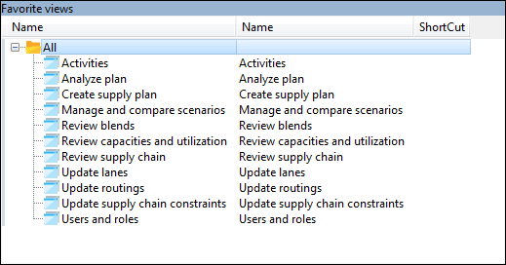

- Go to view ‘Manage and compare scenarios’.
- Load the sales demo using the menu item ‘Select demo dataset’ accessible via the menu ‘Edit’.

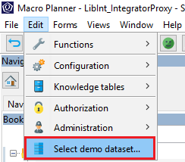

- Select the demo ‘Metals’ and select the scenarios which you want to load, in this case ‘All’.
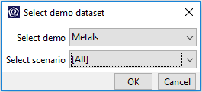

- Delete the scenario ‘Base + Additional shifts on CMs’
- Go to view ‘Users and roles’.
- Select the role ‘SupplyPlanner’, and assign your username as the primary user using the context menu item ‘Set as primary user’ in the ‘Assigned users’ list.
- Select the role ‘DemandPlanner’, and assign your username as the primary user using the context menu item ‘Set as primary user’ in the ‘Assigned users’ list.

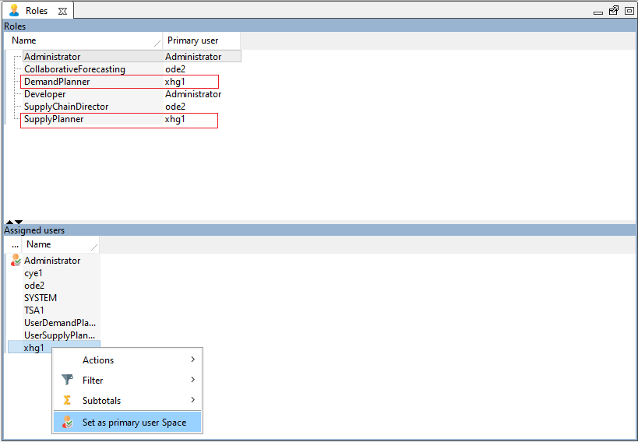

Simplified UI: To simplify the UI in the demo you can hide the UI components corresponding to functionality that will not be demoed. For example, in a Metals company, products typically do not have a shelf life. So to simplify the UI, any UI components that have to do with the functionality shelf life can be hidden. The hidden UI components can include settings, menus and forms.

The overview of the functionalities for which the UI can be shown / hidden can be found here: Forms > Administration > Functionality authorization. Each functionality has a tooltip with a description.

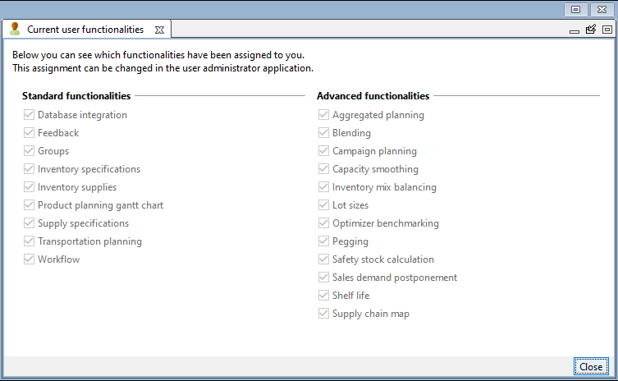

When you log in as an administrator or developer, you will always have all functionalities enabled. For other roles all functionalities are by default disabled. To enable a functionality for a role, use the user administrator application to create an assignment for that role to that functionality in the model user group list. In the example below, the Planner role has access to the functionality shelf life.
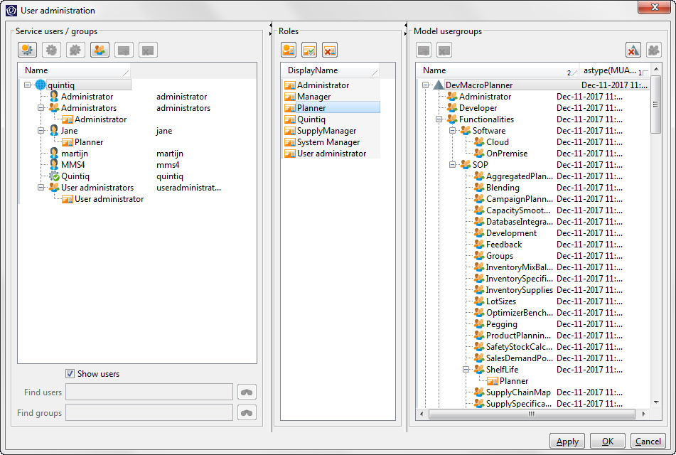

The recommended functionalities for the demo described in this document are: Groups, Inventory specifications, Inventory supplies, Supply specifications, Transport planning, Workflow, Blending, Campaign planning, and Capacity smoothing.

If you have any feedback, please send them to Sanae.HIMDI@3ds.com

You are now ready to demo!

Note:
- Text in this font which is the story you should tell your customer
- Text in this font which are instructions you should perform in the demo
- Text in this font which are helpful hints for you the demo person

Introducing the demo
The demo you are about to see is about QAluminum. QAluminum is a vertically integrated company in the Aluminum production and recycling supply chain.

They operate in 4 different regions and they produce aluminum finished goods in the form of aluminum coils and blocks, for the automobile and can industry in those regions.

Go to view ‘Review supply chain’.

On the overview, drill down onto the QAluminum supply chain to show the operations in 4 different regions.

Then drill down on the Asian supply chain for more details by using the context menu ‘Drill down’ on the nodes.
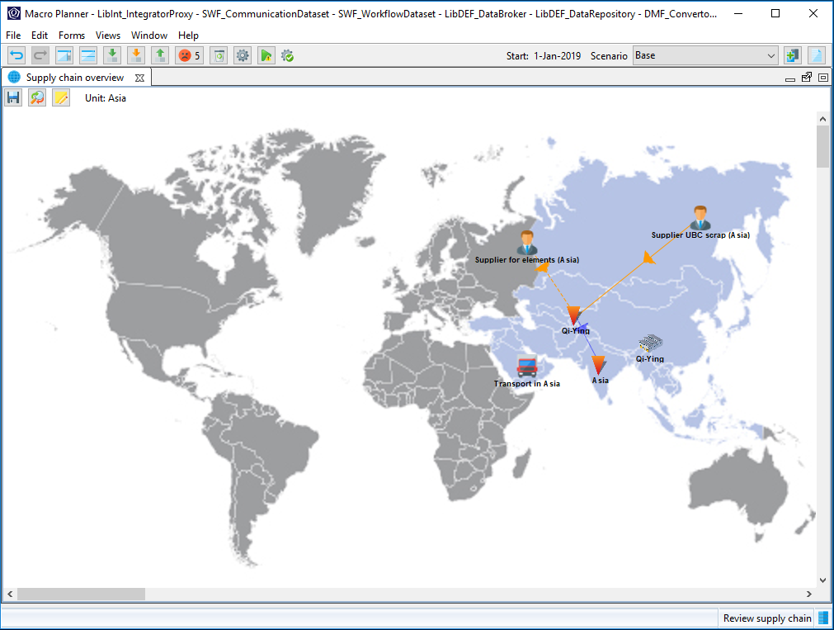

Prime is a key ingredient and it is obtained from international suppliers based in Australia and South America. Alloying elements and recyclable scraps on the other hand, are obtained from local suppliers.

Go to view ‘Update routings’.

Manufacturing covers from melting and casting to finishing.

Operations related to the individual stages are grouped into a single routing. For example, the finishing stage may consists of tension levelling and slitting to produce beverage and food cans.

Select a cast house routing to produce 3XXX ingots.

The finished goods are mainly divided into 2 categories, which are made out of the 3-series and 5-series aluminum alloys. The capability to blend is present in the melt and cast routings.
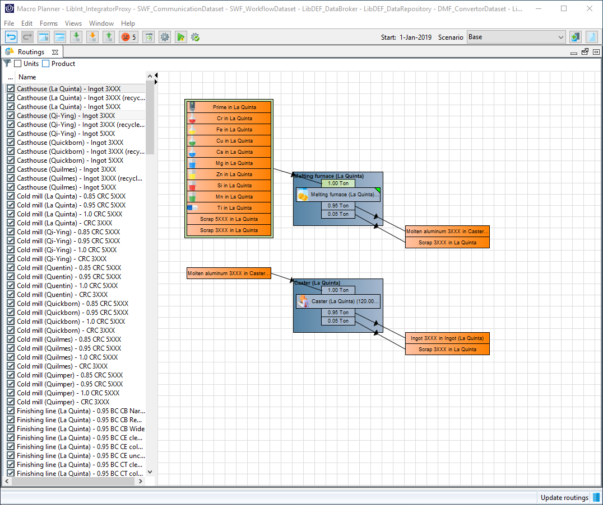

This demo will be conducted using monthly periods.

Show the navigation panel and subsequently the ‘Periods’ list.

Select the ‘Planning periods’.

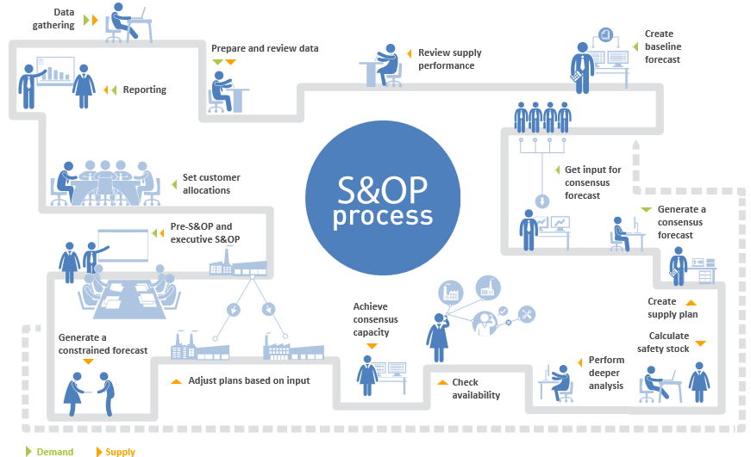

This demo covers the following phases in the S&OP process of the metals industry:
- Prepare and review data
- Review supply performance
- Create supply plan
- Perform deeper analysis
- Check availability
- Pre-S&OP and executive S&OP
- Safety stock

Handle workflow
S&OP is a collaborative and cross-functional planning process, which involves many stakeholders from different departments. Hence, it is important to have the capability to handle the complex workflow as well as empower the users that are involved in the S&OP process.

Show the process dashboard.
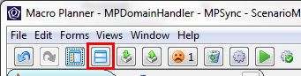

The workflow functionality tracks the progress of the S&OP cycle as well as the activities generated within the cycle.

Go to view ‘Activities’.

Here we see a list of activities. Activities are user or role-specific, and these are the activities that are assigned to the supply planner of the current S&OP cycle.

Put a check next to these 2 activities: ‘Import actuals for DP’, ‘Import actuals for MP’.

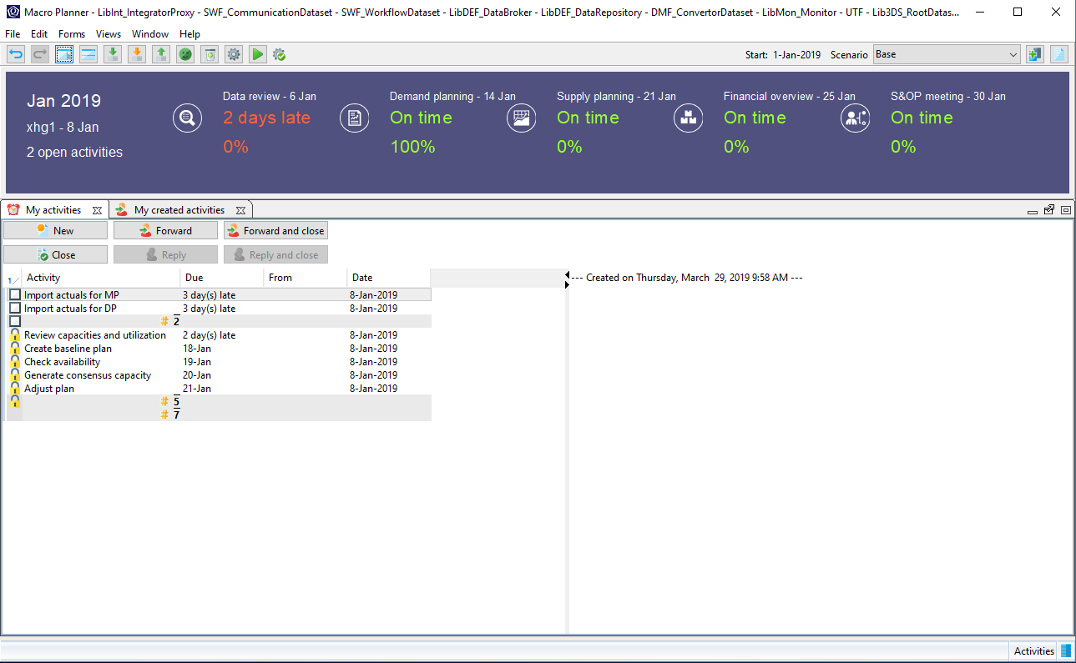
We will now proceed to the first activity assigned to the supply planner.

Compare actuals versus planned
We are now at the beginning of the S&OP cycle and one of the first things to do before going into the actual planning is to review the constraints and performance of our plan. This is typically done against actuals. Macro Planner takes a 3 pronged approach to this, first allowing the import and capture actuals, then the efficient review of actuals against planned, and providing avenues for the reconciliation of deviations.

Go to view ‘Review capacities and utilization’.

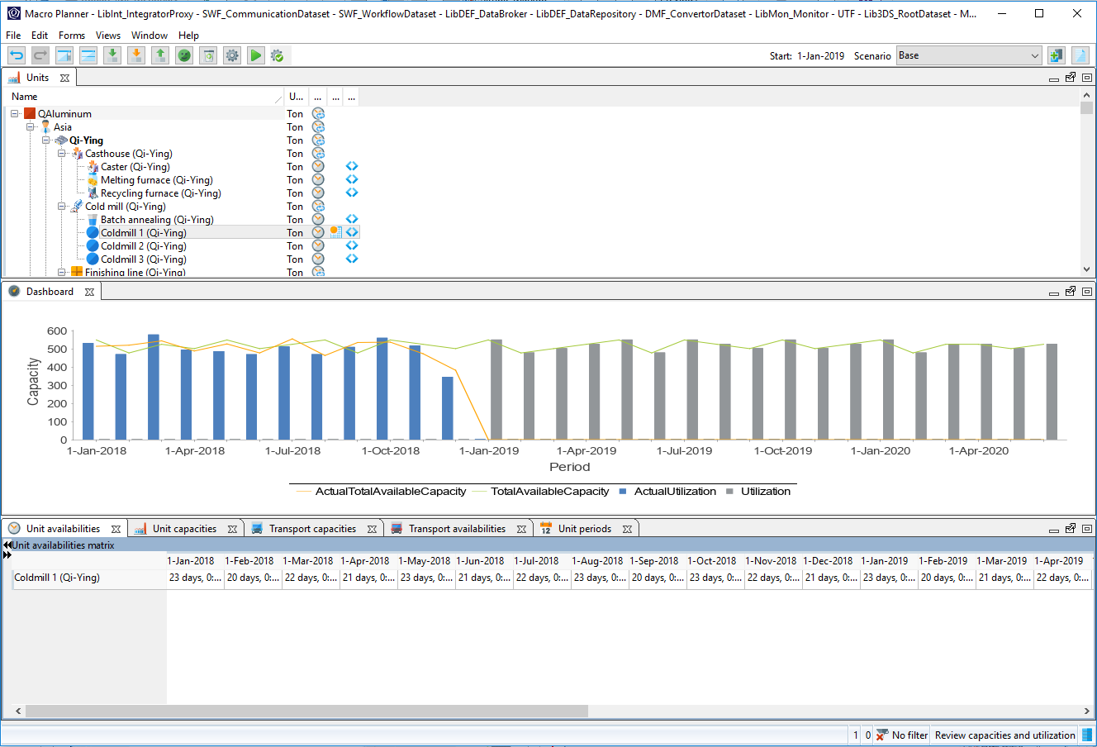
The form ‘Units’ flags the units that you should pay attention to, based on the classification in the global parameters.

Select the unit ‘Cold mill 1 (Qi-Ying)’.

This unit is currently flagged to have an outlier when comparing its planned values against actuals. From the chart, it is clear to be seen that the availability prior to the start of planning has seen a stark drop.
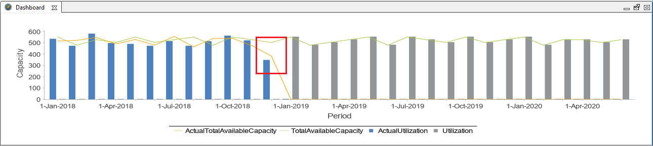

However, after making a few calls to the production floor, we have gathered that the drop was a result of an unscheduled maintenance. In this occurrence, we will resolve this by annotating this in the application.

Select the tab ‘Unit periods’.

Scroll horizontally until you find a highlighted cell.
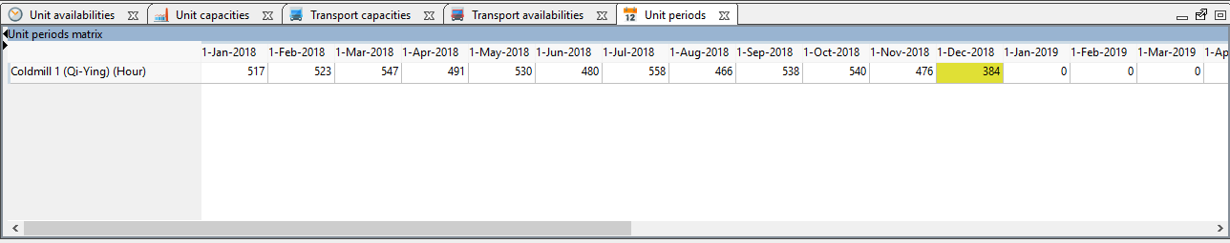

Annotate the occurrence by double-clicking on the cell and leaving a description.
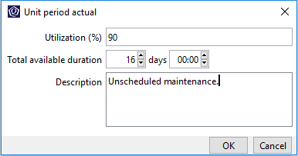

Now that we are done with the reviewing of data, we are going to proceed to analyzing the plan. Before moving to the next step, we are just going to mark the current activity of reviewing the capacities and utilization as complete.

Go to view ‘Activities’, put a check next to ‘Review capacities and utilization’ item in ‘My activities’ list.

Analyze the base plan
Go to view ‘Analyze plan’.

Show the navigation panel and navigate to root.
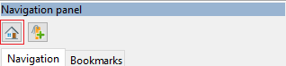

In this view, you will go through with the audience on how to analyze the base plan, do it at an appropriate pace so that the audience can follow.

This is the base plan. We are now going to examine the interesting aspects of this base plan.

OPTIONAL

Blending is a capability unique to Macro Planner. You can further demonstrate this capability if you think it may interest your prospect.

We are now going to take a look at how Macro Planner deals with the presence of different alloys in the creation of the supply plan.

Go to view ‘Review blends’.

Show the navigation panel and select the tab ‘Bookmarks’.

Open the bookmark ‘Review blend’.

Select the product in stocking point ‘Molten aluminum 3XXX in Caster WIP (Quilmes)’ in the period ‘1-Sep-2019’ on the product planning matrix.

Select the tab ‘Period tasks’.

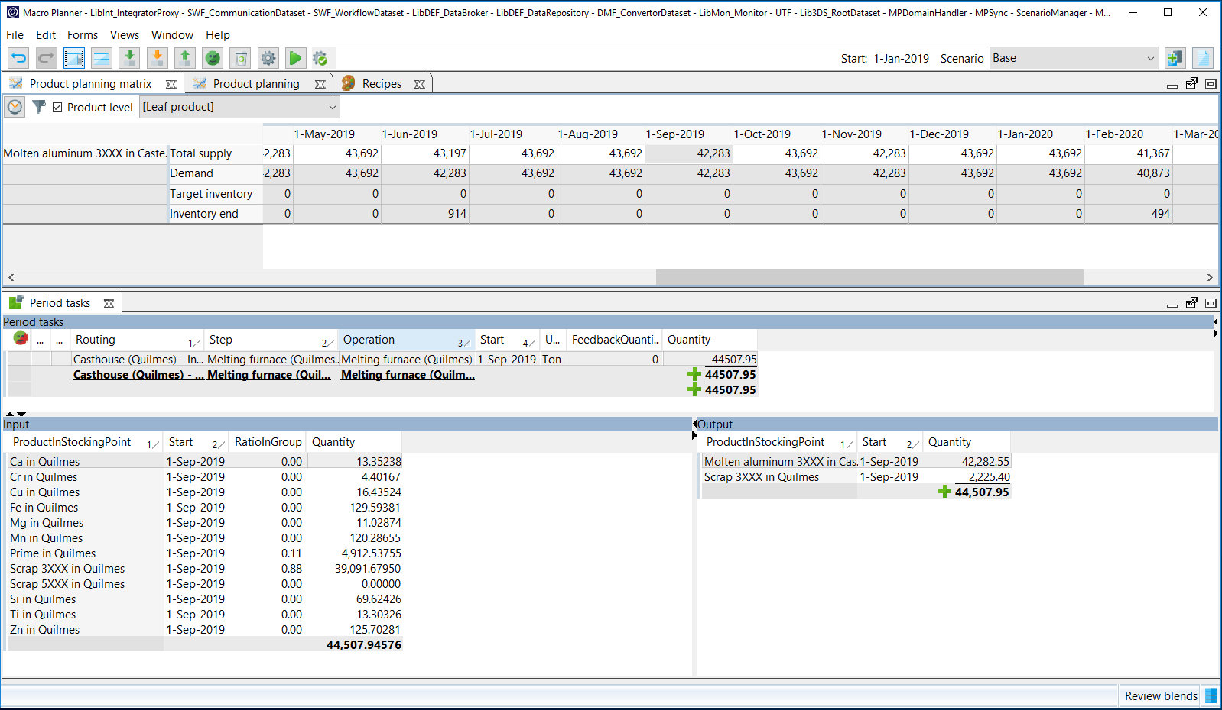

What we see here is the period task involved in producing the intermediate product ‘Molten aluminum 3XXX’ required for the production of 3-series finished goods. Presented here is also the input products for the period tasks, and we can clearly see the blending capability in action here. The by-product ‘Scrap 5XXX’ is used in small traces to augment the production of ‘Molten aluminum 3XXX’, indicating a dynamic Bill-of-Materials (BOM) constrained by the tolerances specified in the recipes.

Go to view ‘Analyze plan’.

Reset to root selection.

The optimizer run on the base plan shows a deficit on ‘CanMan China’ and ‘Special Can’ segments. We will now explore the possibility of improving the service levels rendered to these segments.

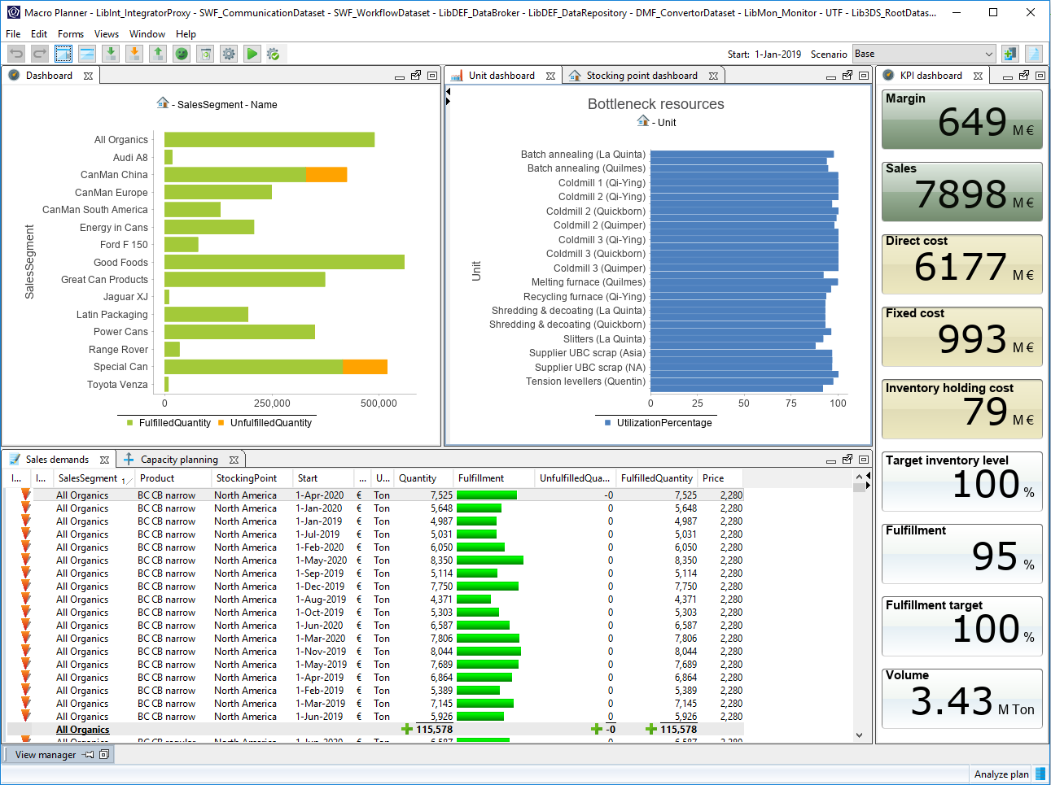

We start off first by identifying the region where the sales segments originated from.

Drill down onto (sales segments) bar charts on the dashboard to see the deficit on a product in stocking point level.

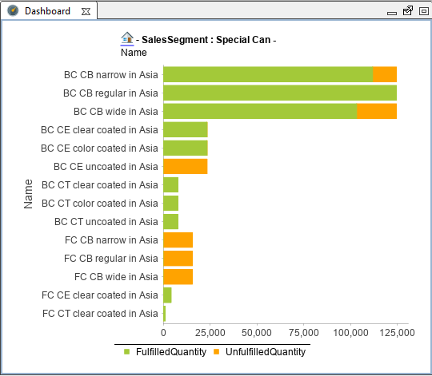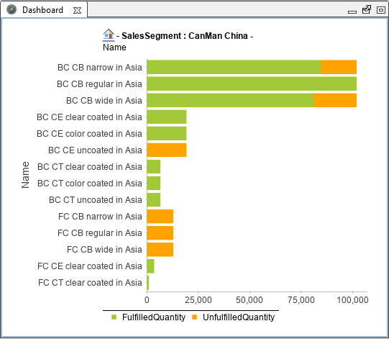

From the drill down of each sales segment, it is clear that the deficit only happens to products in Asia.

Now that we have identified the regions, we are going into further detail to identify the issue that is causing the deficit.

Select the tab ‘Unit dashboard’.

The ‘Unit dashboard’ shows the potentially bottlenecked resources based on the classification in the global parameters.

Show the navigation panel and select the tab ‘Bookmarks’.

Open the bookmark ‘Asia’.

The ‘Unit dashboard’ will show all the bottlenecked units (including the child units) based on the selection in the list of units in the navigation panel.
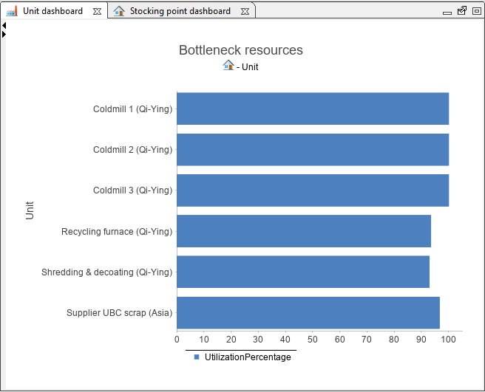

It is clear from the ‘Unit dashboard’ that the cold mills in the Qi-Ying plant are the manufacturing bottlenecks. To further verify this:

Select the tab ‘Capacity planning’.

Show the navigation panel and select the tab ‘Bookmarks’.

Open the bookmark ‘Coldmill (Qi-Ying)’.

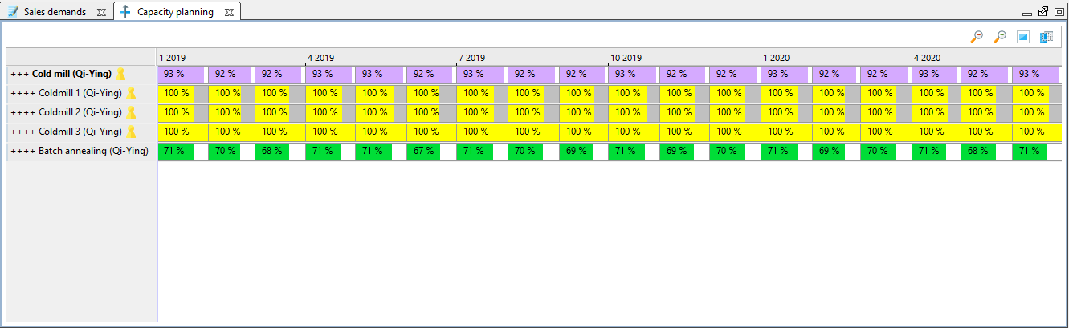

The capacity planning charts shows that all the cold mills in the Qi-Ying plant are fully utilized. However, it is also obvious from the capacity planning chart that ‘Coldmill 1 (Qi-Ying)’ and ‘Coldmill 2 (Qi-Ying)’ are not operating at its maximum capacity. This will become the basis of our first what-if scenario.

Create what-if scenario
A what-if scenario is a sand-boxed environment isolated from the base plan which you can use to experiment and simulate potential scenarios.

Click on the ‘Copy current scenario’ button on the toolbar.

You will be presented with a dialog with options for your what-if scenarios.

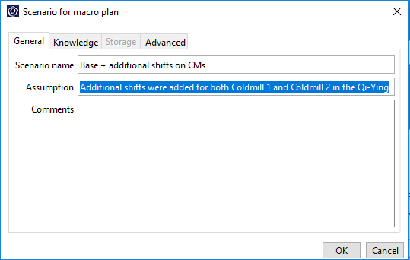

Fill in the appropriate fields and click on ‘OK’.

A what-if scenario is now created and that scenario is now made the active scenario as evident from the scenario drop-down.

NB. If the application does not allow you to create a copy of the scenario, this is because you reached the maximum number of online scenarios. You can increase this maximum number in the sizing parameters by selecting Edit > Configuration > Sizing parameters (not available on the cloud). Alternatively, you can delete some scenarios in the Manage and compare scenarios view.

Scenario: Base + additional shifts on CMs
In this what-if scenario, we are going to explore the possibility of increasing the shifts on the cold mills in Qi-Ying and observe the consequences.

Edit the capacity of the unit ‘Coldmill 1 (Qi-Ying)’ and ‘Coldmill 2 (Qi-Ying)’ using the context menu ‘Edit capacity’ on the capacity planning chart.

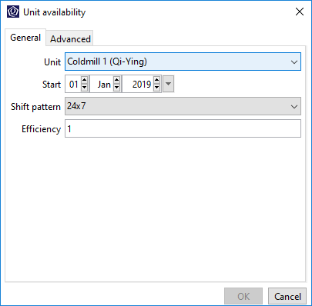

Define Start date ’01-Jan-2019’.

Select the shift pattern ‘24x7’.

Click on ‘OK’.

Realize that the units ‘Coldmill 1 (Qi-Ying)’ and ‘Coldmill 2 (Qi-Ying)’ are now no longer fully utilized. This is because that we have just used a greater shift pattern which allows the unit to operate 24 hours and 7 days a week.

After updating the supply chain parameters, the Coldmills now have additional capacities. The tradeoff for these additional capacities is the increase in staffing costs, denoted by the fixed costs KPI. An optimizer run is necessary to update the plan based on the new parameters.

Click on the ‘Run the optimizer with the last used settings’ button.

The optimizer run will proceed in the background and it will take anytime less than a minute, in the meantime, you can take this opportunity to explain the configurations of the optimizer and how it can provide the user with goal-based optimization.

Click on the ‘Open optimizer dialog’ button.

The optimizer dialog will appear.

Click on the ‘Edit strategy’ button to bring up the strategy dialog.

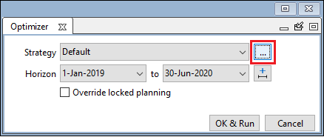

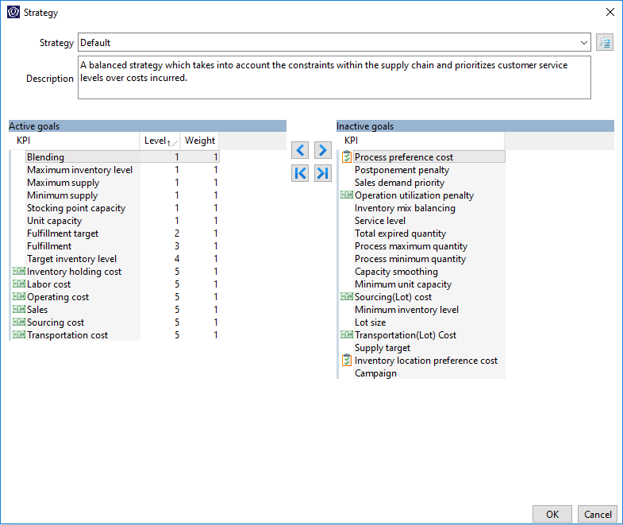

The Macro Planner optimizer uses a KPI-based optimization approach, which allows the planner to create supply plans which aligns with the business goals and strategies of their organization.

The key message here is that the Macro Planner optimizer will not play its traditional role of obtaining the most optimized supply plan in the shortest time, but rather, it serves as tool for the planner to plan the many possible scenarios, taking into account the business strategies and goals of their organization. And finally evaluate the scenarios.

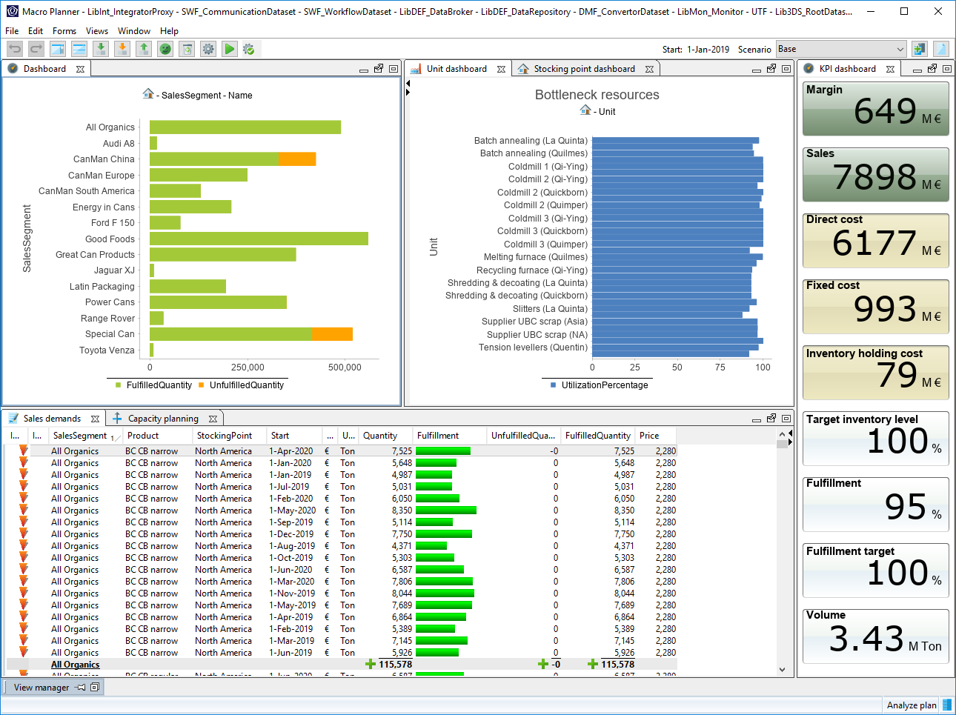

With the optimization run completed, we are now going to compare the changes in KPIs.

Compare scenarios
Go to view ‘Manage and compare scenarios’.

Select both the scenarios ‘Base’ and ‘Base + additional shifts on CMs’.
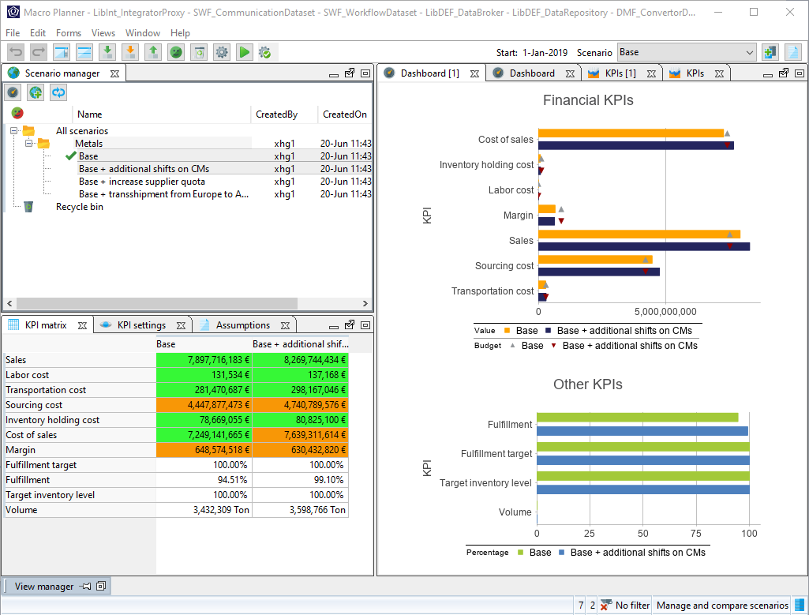

Realize that the ‘Fulfillment’ KPI has improved from 95% to 99%. The gains in the ‘Fulfillment’ KPI is clear to be seen. However, people will often ask what is the trade-off, if there are any, in achieving this?

If you have a keen eye, you would have realized by now, that there is a degradation in absolute margin. This is because, the gains in revenue is being offset by the increase in cost of sales.

What was discussed above are the high-level comparisons in the form of KPIs, which will certainly interest the management. However, S&OP is an integrated business management process which encompasses many people from different departments. With the additional shifts, we are now going to see the effects of this what-if scenario on the resource utilization.

Select both the scenarios ‘Base’ and ‘Base + additional shifts on CMs’.

Compare the resource availability and utilization by using the context menu ‘Compare’ followed by ‘Unit periods’ with both the scenarios selected.
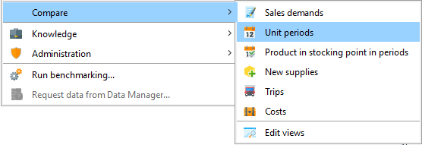

You will be presented with a new view.

Show the navigation panel and select the tab ‘Bookmarks’.

Open the bookmark ‘Coldmill (Qi-Ying)’.

The view will now look like this.

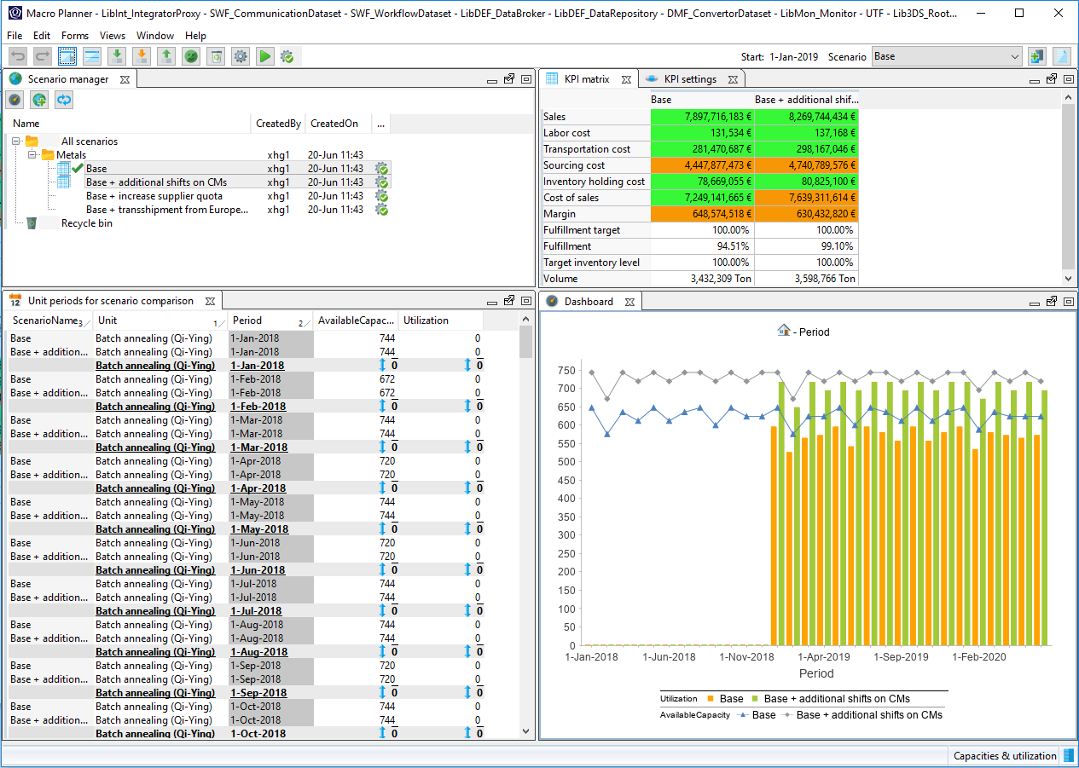

It is clear from the dashboard charts comparing the capacities, that the increase in availability of the cold mills are well utilized.

OPTIONAL

Optionally, you can demo the robustness of the scenario comparison by demonstrating the comparison of output quantities.

With the additional shifts, the production manager is now interested in seeing the effects of this what-if scenario on the output quantities.

Select both the scenarios ‘Base’ and ‘Base + additional shifts on CMs’.

Compare the output quantities by using the context menu ‘Compare’ followed by ‘New supplies’ with both the scenarios selected.

Show the navigation panel and select the tab ‘Bookmarks’.

Open the bookmark ‘Finishing line (Qi-Ying)’.

You will be presented with a view which shows the output quantities for the different finished goods.

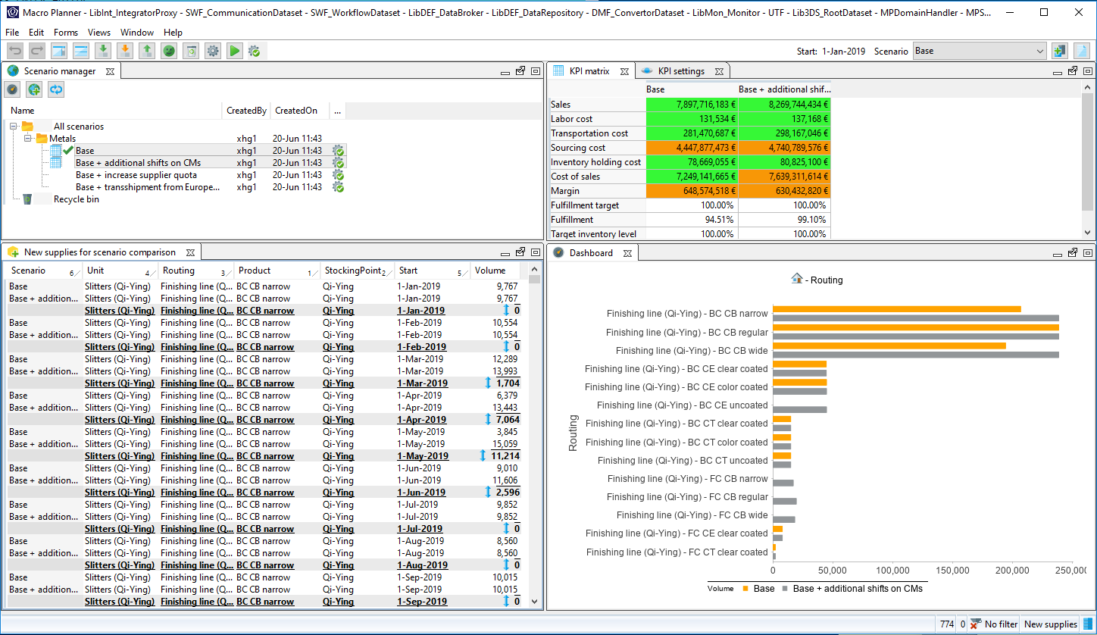

All in all, by comparing the scenarios, you are now equipped with sufficient knowledge and are clear about the trade-offs, which can be useful during the discussion in the S&OP meeting. Next up, we would like to determine the viability of the scenario by running it through the relevant departments, in this case, subjecting the proposal to the verification of the Human Resource department.

Create scenario activity
Process and workflow support are important elements of an S&OP implementation. For the what-if scenario of additional shifts on the cold mills of Qi-Ying, we are going to create an activity for the factory manager to review and verify the additional shifts.

Go to view ‘Activities’.

Click on the button ‘New’.

On the activity dialog, fill in the following:

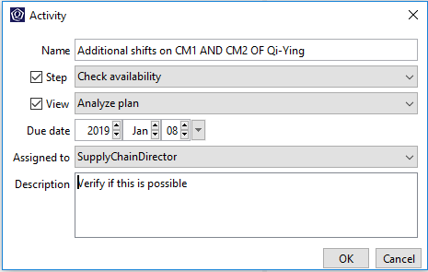

Click on ‘OK’.

This would then create an activity for the Supply chain director, which would be visible the next time he or she logs in to the Quintiq application.

Scenario: Base + transshipment from Europe to Asia
Remember to already create a scenario for this, load the appropriate data and run the optimizer, as the following steps will not cover these. Instead, these are covered in the ‘Preparation’ section.

In this what-if scenario, we are going to explore the possibility of setting up a transshipment lane between Europe and Asia to address the deficit in service rendered to the sales segment ‘CanMan China’ and ‘Special Can’ as seen in the ‘Base’ scenario.

Go to view ‘Update lanes’.
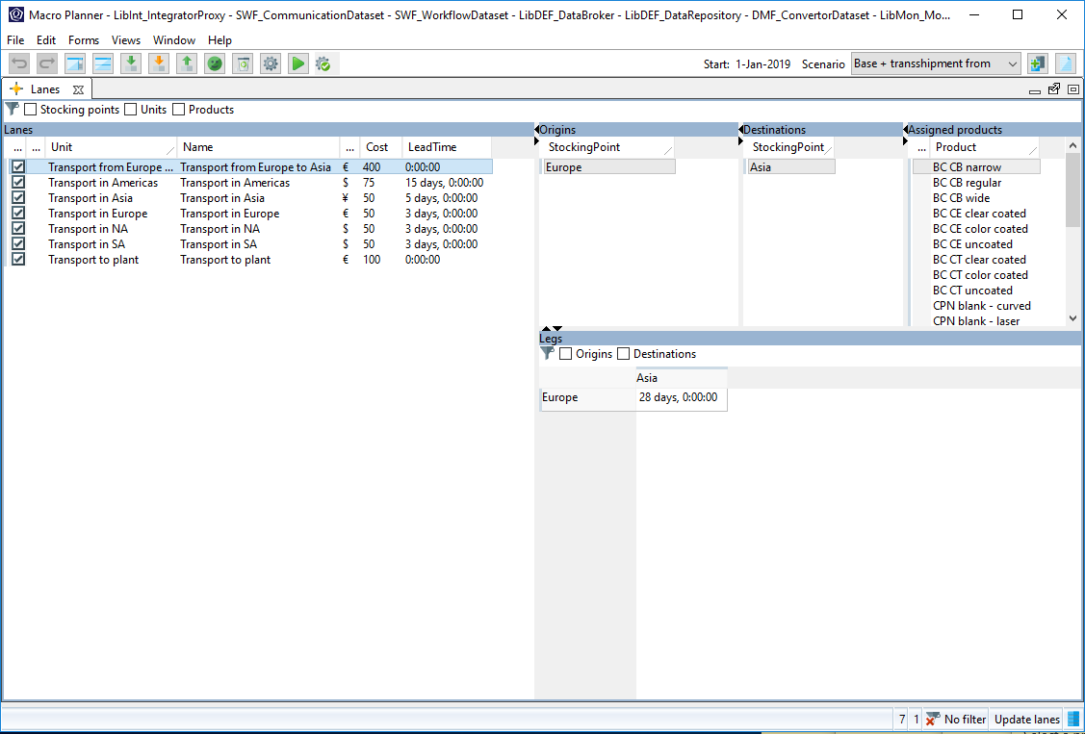

Select the lane ‘Transport from Europe to Asia’.

We have added a lane, which moves the automotive and can based finished goods from Europe to Asia. This scenario leverages on the available capacity in Europe to help co-supply the demands generated in the Asian region.

We are now going to compare this hypothetical scenario against the base scenario.

Go to view ‘Manage and compare scenarios’.

Select both the scenarios ‘Base’ and ‘Base + transshipment from Europe to Asia’.

The KPI comparison shows the gains made in fulfillment, and the rise in cost for transportation, sourcing and inventory holding, resulting in the decline of absolute margin. Next up, the logistics manager is going to be very interested in seeing how the introduction of this transshipment route is going to affect the existing routes.

Show the navigation panel and navigate to root.
Compare utilization of the routes by using the context menu ‘Compare’ followed by ‘Trips’ with both the scenarios selected.

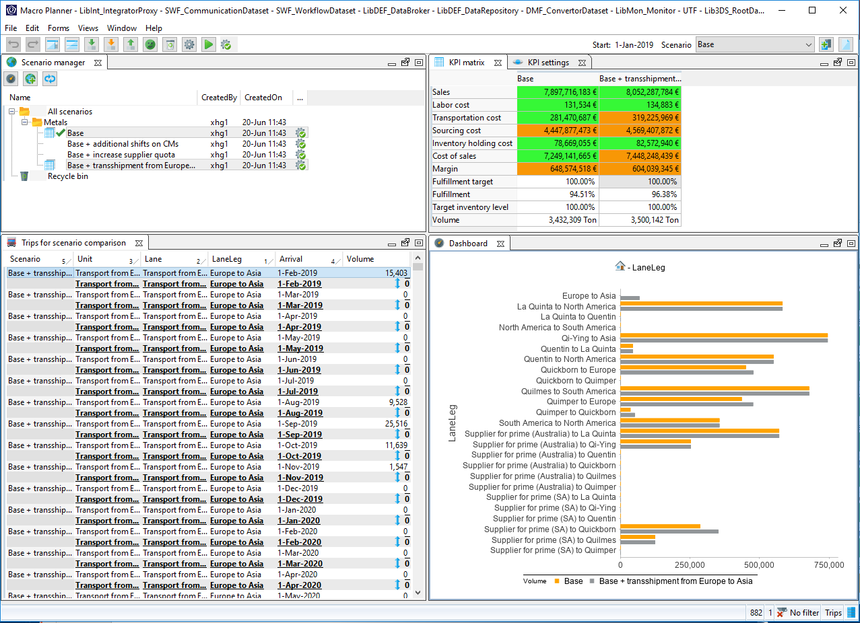

Besides the obvious new transshipment route, we can also see that the volumes moved between the supplier for Prime based in South America to the Quickborn plant will see an increase. Perhaps it is a good time to negotiate for a more beneficial agreement with the transport provider?

OPTIONAL

You can also create an activity for the logistics manager to examine the possibility of this scenario.

Scenario: Base + increase supplier quota
Remember to already create a scenario for this, load the appropriate data and run the optimizer, as the following steps will not cover these. Instead, these are covered in the ‘Preparation’ section.

In this what-if scenario, we are going to explore the possibility of increasing the supplier quota for UBC scrap based in Asia by 50% from April onwards. This is triggered by the analysis of the base scenario where the supplier is potentially a bottleneck.

Go to view ‘Update supply chain constraints’.

Select the tab ‘Unit capacities’.
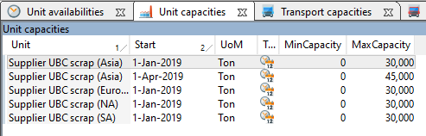

We have updated the constraints of the UBC scrap supplier based in Asia from 30,000 to 45,000 from April onwards. This scenario examines the alleviation of the supplier as a bottleneck and its impact on our KPIs, and to a certain extent, financials.

We are now going to compare this hypothetical scenario against the base scenario.

Go to view ‘Manage and compare scenarios’.

Select both the scenarios ‘Base’ and ‘Base + increase supplier quota’.

The KPI comparison shows the significant reduction in transportation and sourcing costs, resulting in the gain of absolute margin. Next up, the sourcing manager is going to be very interested in seeing how the increase in quota is going to affect the monthly budget for sourcing.

Select both the scenarios ‘Base’ and ‘Base + increase supplier quota’.

Compare costs incurred by using the context menu ‘Compare’ followed by ‘Costs’ with both the scenarios selected.

Filter the form ‘Cost for scenario comparison’ to only show ‘Units’.

Show the navigation panel and select the tab ‘Bookmarks’.

Open the bookmark ‘Supplier UBC scrap (Asia)’.

Select the ‘Units’ option on the ‘Cost for scenario comparison’ list

Select both the instances of ‘Sourcing cost’.
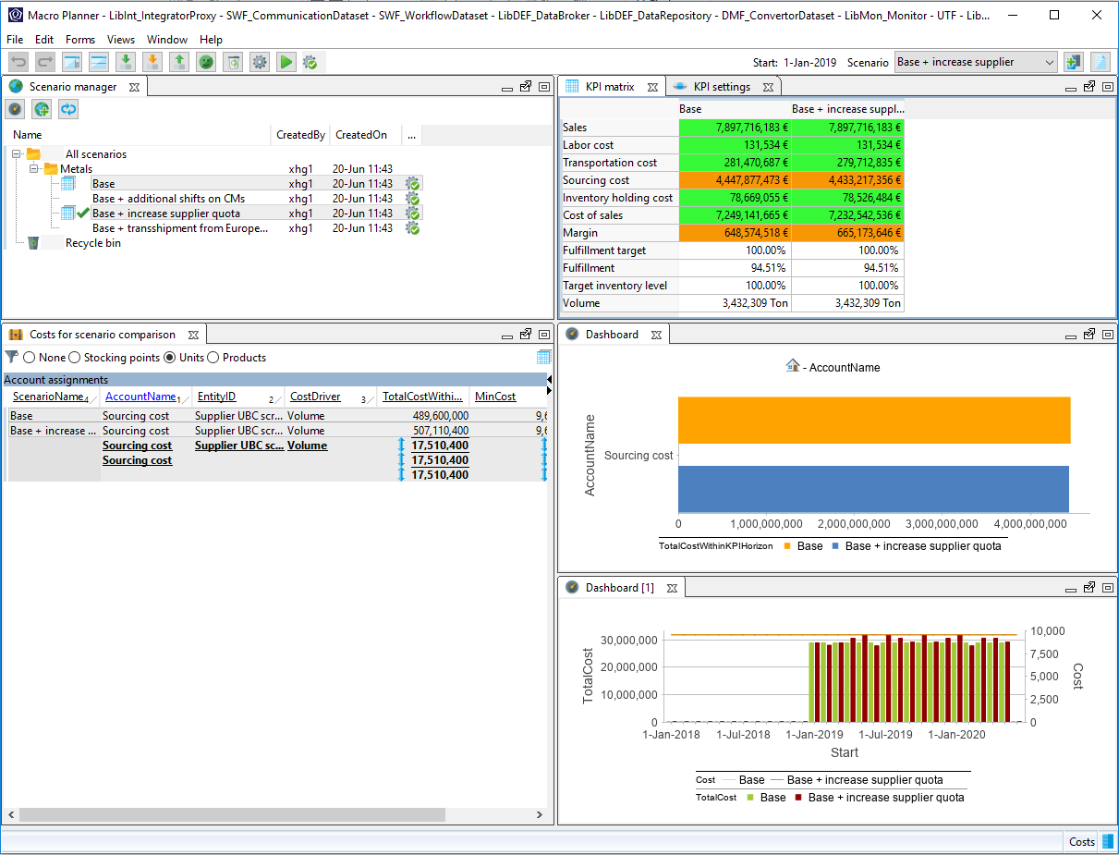

We can see that the total cost incurred per period here is minimal. The benefit of comprehensive S&OP tool is clear to see here, where the organization can spot opportunities, and improve the overall efficiency of the supply chain.

OPTIONAL

You can also create a scenario activity for the sourcing manager to examine the possibility of this scenario.

Scenario: Base + additional production capacity
In this what-if scenario, we are going to explore the possibility of the sales team leveraging on the additional production capacity of one of our intermediate products (CRC 3XXX) in the Qi-Ying plant, made available to us in the month of April by the factory manager.

Create a copy of the Base scenario. Click on the ‘Copy current scenario’ button on the toolbar.

NB. If the application does not allow you to create a copy of the scenario, this is because you reached the maximum number of online scenarios. You can increase this maximum number in the sizing parameters by selecting Edit > Configuration > Sizing parameters (not available on the cloud). Alternatively, you can delete some scenarios in the Manage and compare scenarios view.

You will be presented with a dialog with options for your what-if scenarios.

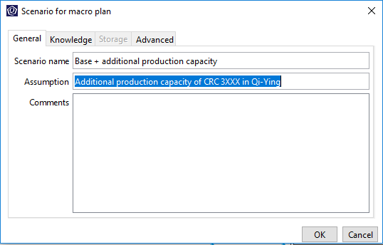

Fill in the appropriate fields and click on ‘OK’.

A what-if scenario is now created and that scenario is now made the active scenario as evident from the scenario drop-down.

Go to view ‘Create supply plan’.

Open the bookmark ‘CRC 3XXX in CRC (Qi-Ying)’.

Select the cell in the form ‘Product planning matrix’ bearing the product in stocking point ‘CRC 3XXX in CRC (Qi-Ying)’ in the period ‘1-Apr-2019’. Bring up the context menu and select the option ‘Smart plan…’.

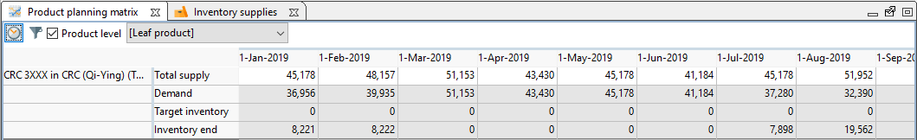

On the dialog ‘Smart plan’, check the option ‘Total supply’ and enter a value of 60,000. Subsequently, select the tab ‘Advanced’ and select the radio option ‘Middle-out’. Click on ‘OK’.

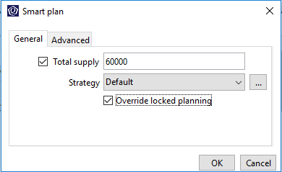

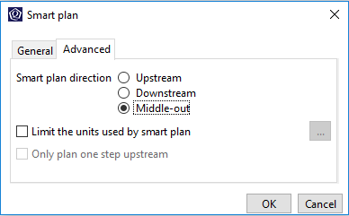

This will trigger a middle-out smart plan run with the specified quantity on the product in stocking point in period. Smart plan can be described as optimizer-supported manual planning / local planning. Depending on the direction of the smart plan, in this case ‘Middle-out’, smart plan would ensure that the upstream and downstream relative to the selected product in stocking point in period is planned based on the specifications (e.g. total supply).

We can ignore the sanity check violation raised from the previous action as the factory manager has promised us the additional supply and it is irrelevant to this scenario.

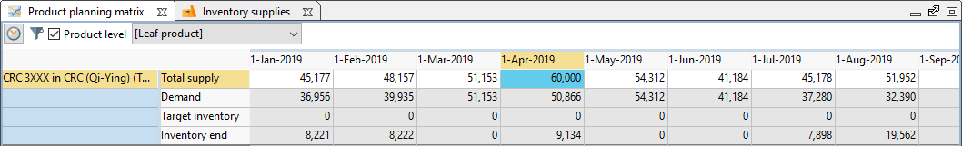

In the meantime, let’s take a look at the supply stream of the product in stocking point in period in question to see which finished goods can possibly benefit from the additional supply.

Select the tab ‘Supply chain visualization’.

From the supply chain visualization, we can see the finished goods which are derivatives of the food and beverage cans.

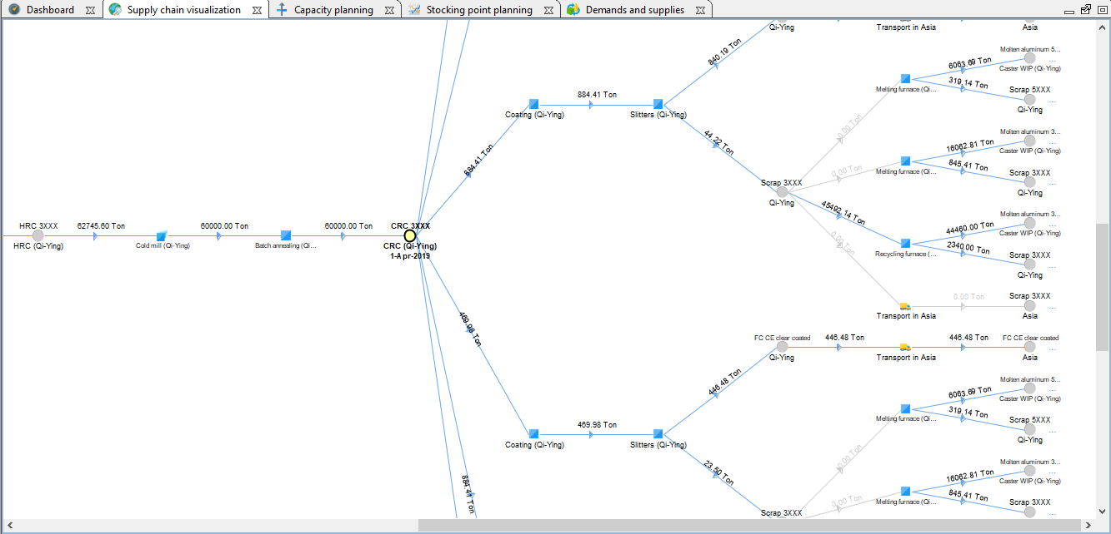

We are now going to compare this hypothetical scenario against the base scenario.

Go to view ‘Manage and compare scenarios’.

Select both the scenarios ‘Base’ and ‘Base + additional production capacity’.

The KPI comparison shows a slight increase in fulfillment at the expense of our margin. Next up, the sales team is going to be very interested in seeing which of their sales segments would benefit from this scenario.

Select both the scenarios ‘Base’ and ‘Base + additional production capacity’.

Compare the fulfillment of sales demands by using the context menu ‘Compare’ followed by ‘Sales demands’ with both the scenarios selected. (If the list and dashboard are empty, select the home button on the navigation panel to select all the data.)

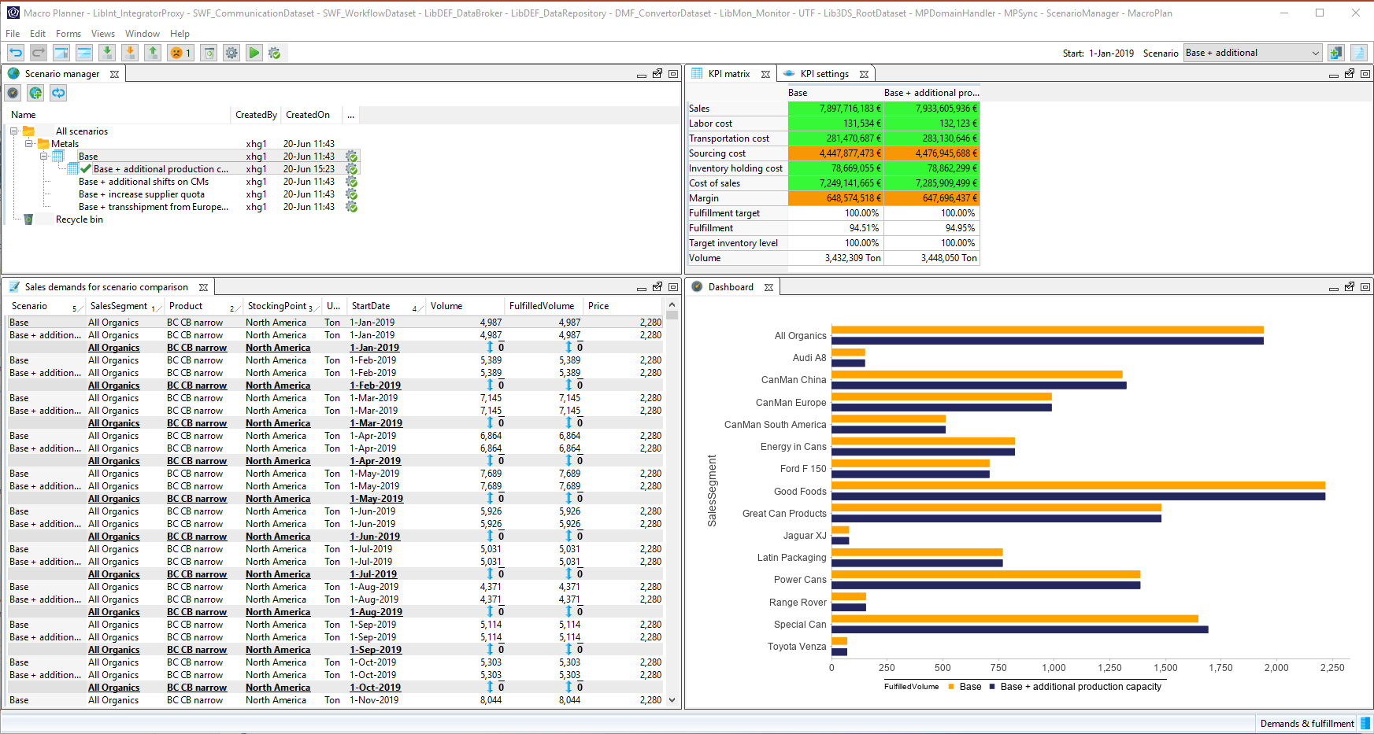

We can see that there is a slight increase in fulfillment for our customer ‘Special Can’ or ‘CanMan China’, which is no surprise, since it was pointed out earlier that the derivatives of food and beverage cans may potentially benefit from the additional production of the intermediate product. Perhaps, the sales team would be very happy to hear this.

OPTIONAL

You can also create a scenario activity for the sales team to examine the possibility of this scenario.

Summary
Create your own what-if scenarios to align to the interest of your prospect.

Further align the demo of comparison between the what-if scenarios to the business goals and strategies of the prospect that you are pitching to, by making use of the functionality to compare scenarios in detail.

Also emphasized that planning and decision-making are driven by KPIs.

These scenarios give us a powerful ability to complete a full S&OP cycle rapidly and make assessments of all the opportunities which may exist. The ability to represent your physical supply chain accurately, rapidly change the supply chain and constraint data, in a S&OP process driven structure set up for the optimization runs to produce the plans. You then select the right strategy for optimization, and then run and compare multiple scenario’s giving your S&OP the power needed to ensure that the Executive SOP Meeting is fully informed of all the opportunities and can make the best choices with the complete set of information available.

