S&OP food demo – Macro Planner
Contents
S&OP food demo – Macro Planner 1
Preparation 2
Introducing the demo 6
Handle workflow 10
Compare actuals versus planned 11
Analyze the base plan 13
Create what-if scenario 16
Scenario: Base + additional shifts for packaging 17
Compare scenarios 20
Create scenario activity 24
Scenario: Base + transport option 24
Scenario: Base + Denmark shutdown 27
Scenario: Base + rework 32
Scenario: Base + adjust fulfillment 34
Summary 41

This script is to be used with Macro Planner 6.0.2 release

Preparation
Follow these steps to get Macro Planner running:
- Install the latest Quintiq Software.
- Load the latest Macro Planner model from the Solutions Portal.
- To enable internal storage, make sure that the ports between QServer and DBODBC are configured properly. This means your data and changes will be saved when restarting. You can learn more on how to configure the internal storage via the e-learning: Internal Data Configuration - OCI & Dataset Store.
- Start the Quintiq ODBC integrator, Quintiq Server, Quintiq TCE, and Quintiq TC.

Once Macro Planner is running, continue with the following steps:
- Assign the views in the folder ‘Sales demo S&OP food views’ as favorites as we will be using them throughout the demo.

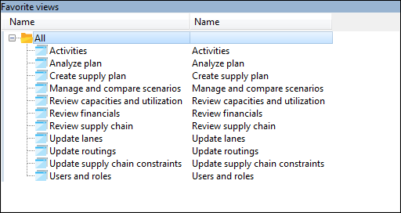

- Go to view ‘Manage and compare scenarios’.
- Load the sales demo using the menu item ‘Select demo dataset’ accessible via the menu ‘Edit’.

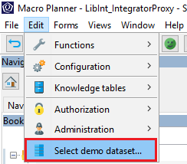

- Select the demo ‘Food’ and select the scenario which you want to load, in this case ‘[All]’.
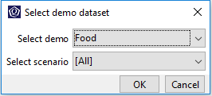

- Delete the scenario ‘Base + additional shifts for packaging’
- Go to view ‘Users and roles’.
- Select the role ‘SupplyPlanner’, and assign your username as the primary user using the context menu item ‘Set as primary user’ in the ‘Assigned users’ list.
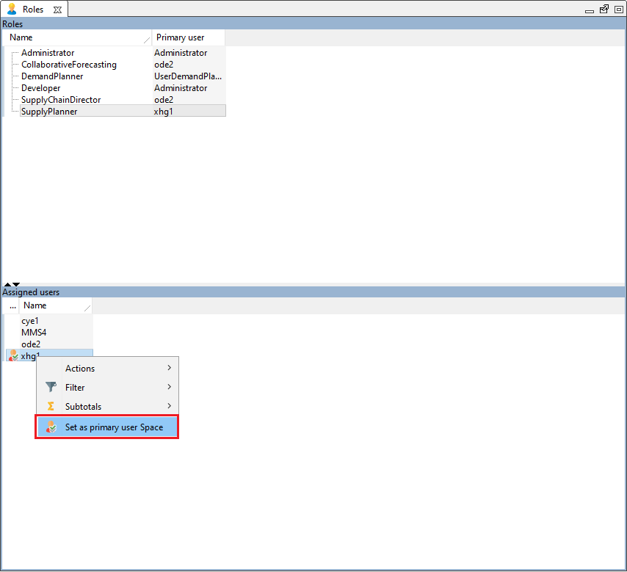

Simplified UI: To simplify the UI in the demo you can hide the UI components corresponding to functionality that will not be demoed. For example, in a Metals company, products typically do not have a shelf life. So to simplify the UI, any UI components that have to do with the functionality shelf life can be hidden. The hidden UI components can include settings, menus and forms.

The overview of the functionalities for which the UI can be shown / hidden can be found here: Forms > Administration > Functionality authorization. Each functionality has a tooltip with a description.

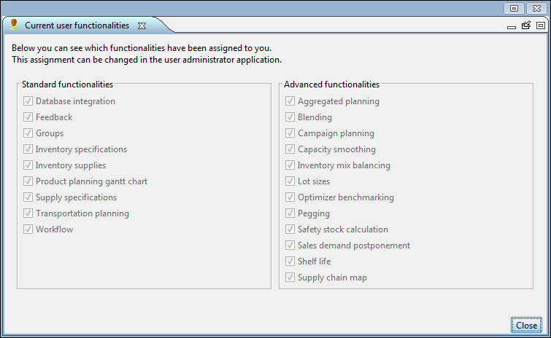

When you log in as an administrator or developer, you will always have all functionalities enabled. For other roles all functionalities are by default disabled. To enable a functionality for a role, use the user administrator application to create an assignment for that role to that functionality in the model user group list. In the example below, the Planner role has access to the functionality shelf life.

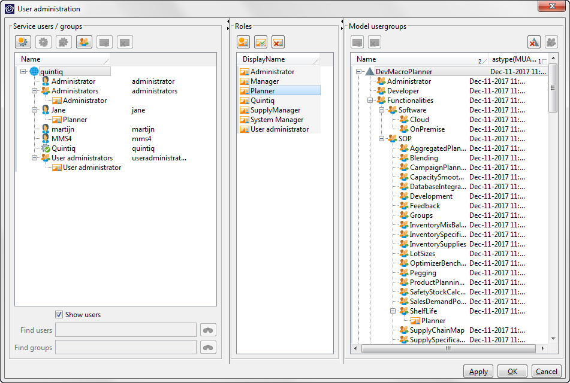

The recommended functionalities for the demo described in this document are: Groups, Inventory specifications, Inventory supplies, Supply specifications, Transport planning, Workflow, Capacity smoothing, and Shelf life.

If you have any feedback, please send them to Sanae.HIMDI@3ds.com

You are now ready to demo!

Note:
- Text in this font which is the story you should tell your customer
- Text in this font which are instructions you should perform in the demo
- Text in this font which are helpful hints for you the demo person

Introducing the demo
The demo you are about to see is about Yoghurt Ltd, a company that produces and sells yoghurt.
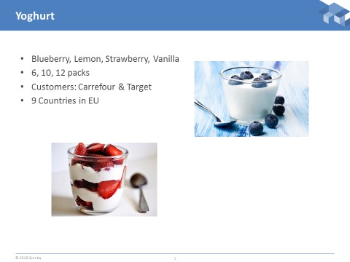

They sell yoghurt in 4 different flavors and 3 different pack sizes to 2 big supermarket chains with stores in 9 European countries. They have 3 manufacturing sites: France, Hungary and Denmark which serves the distribution centers as shown.

Go to view ‘Review supply chain’.

On the overview, drill down onto the European supply chain to show the supply chain in detail.
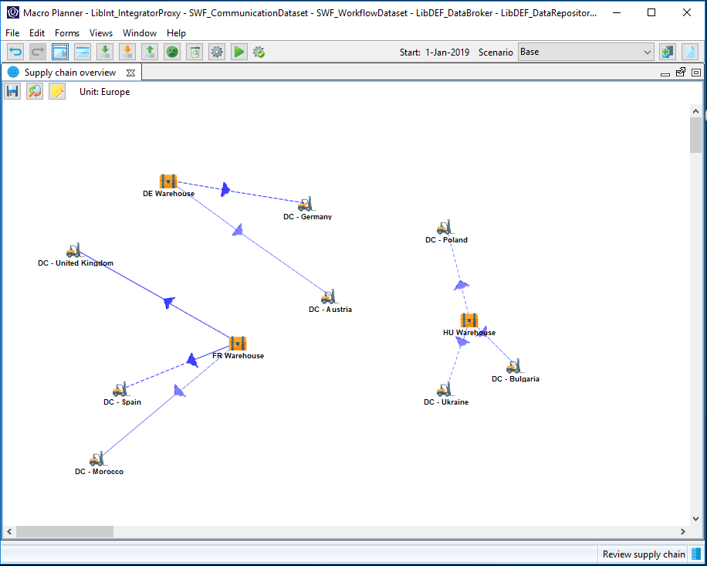

There are routings for manufacturing and for supply.

Manufacturing is two stages, the first uses milk to create White Mass, which can be stored for a maximum of 2 days and the second is the conversion of this into flavored cups of yoghurt into pallets for distribution.

There are no cartons in the BOM, add these if you wish.

Some finished goods use Strainers and some do not.

Go to view ‘Update routings’.

Select the routing which produces DE Greek Blueberry 12 pk.
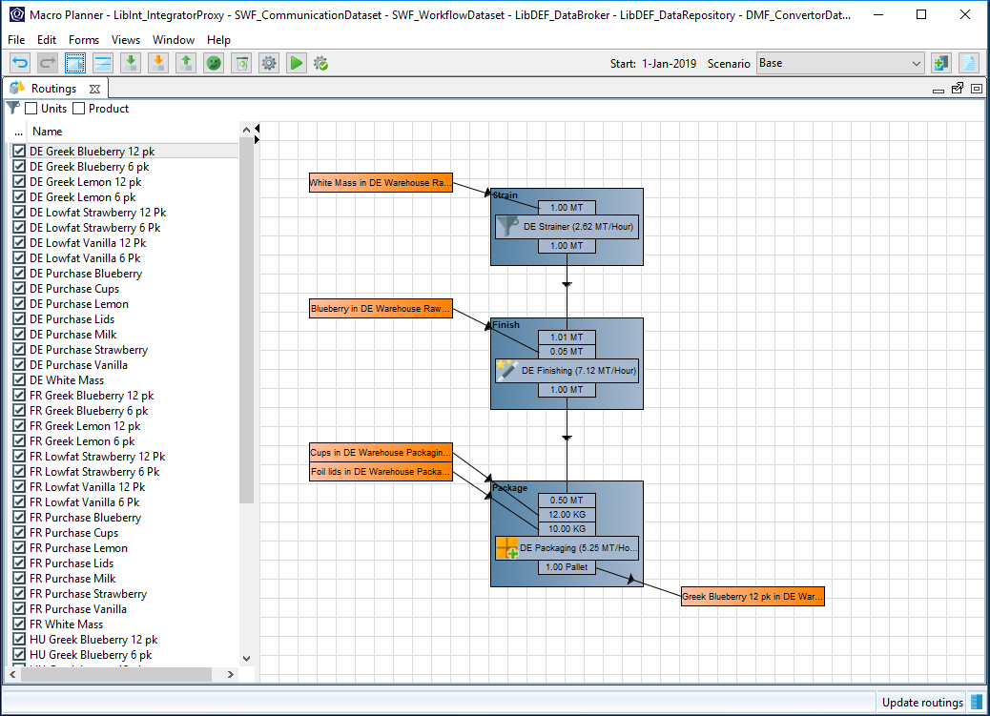

Flavorings are obtained from one of two suppliers

The goal of this demo is to focus on the use of scenarios in S&OP planning in the food industry.

This demo will be conducted using monthly periods.

Show the navigation panel and subsequently the ‘Periods’ list.

Select the ‘Planning periods’.

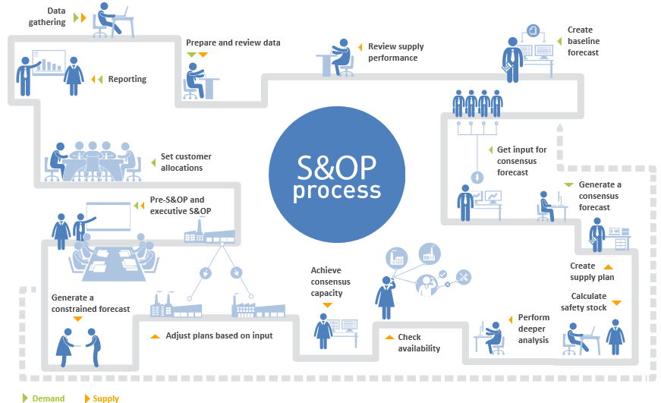

This demo covers the following phases in the S&OP process of the food industry:
- Prepare and review data
- Review supply performance
- Create supply plan
- Perform deeper analysis
- Check availability
- Pre-S&OP and executive S&OP
- Safety stock

Handle workflow
S&OP is a collaborative and cross-functional planning process, which involves many stakeholders from different departments. Hence, it is important to have the capability to handle the complex workflow as well as empower the users that are involved in the S&OP process.

Show the process dashboard.
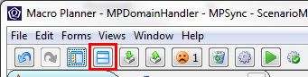

The workflow functionality tracks the progress of the S&OP cycle as well as the activities generated within the cycle.
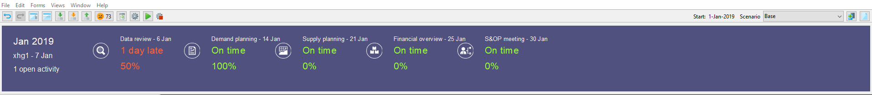

Go to view ‘Activities’.

Here we see a list of activities. Activities are user or role-specific, and these are the activities that are assigned to the supply planner of the current S&OP cycle.
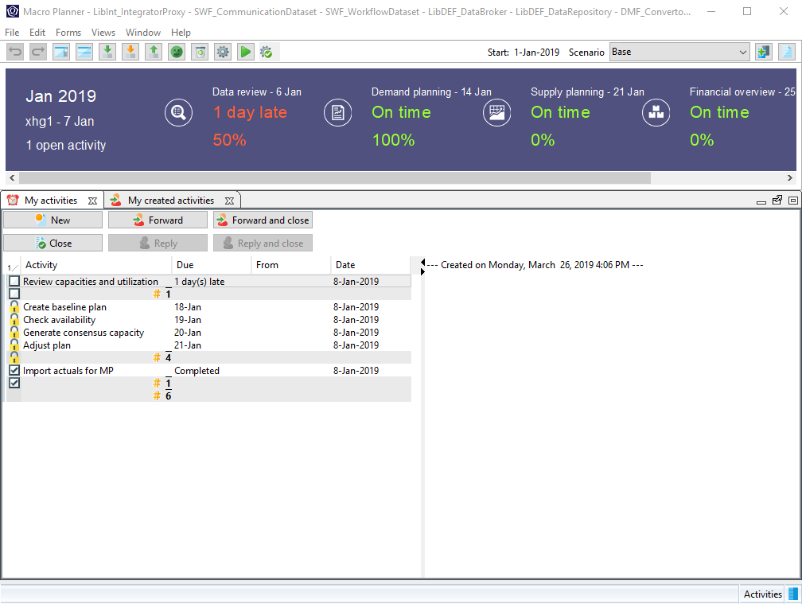
We will now proceed to the first activity assigned to the supply planner.

Compare actuals versus planned
We are now at the beginning of the S&OP cycle and one of the first things to do before going into the actual planning is to review the constraints and performance of our plan. This is typically done against actuals. Macro Planner takes a 3 pronged approach to this, first allowing the import and capture of actuals, then the efficient review of actuals against planned, and providing avenues for the reconciliation of deviations.

Go to view ‘Review capacities and utilization’.
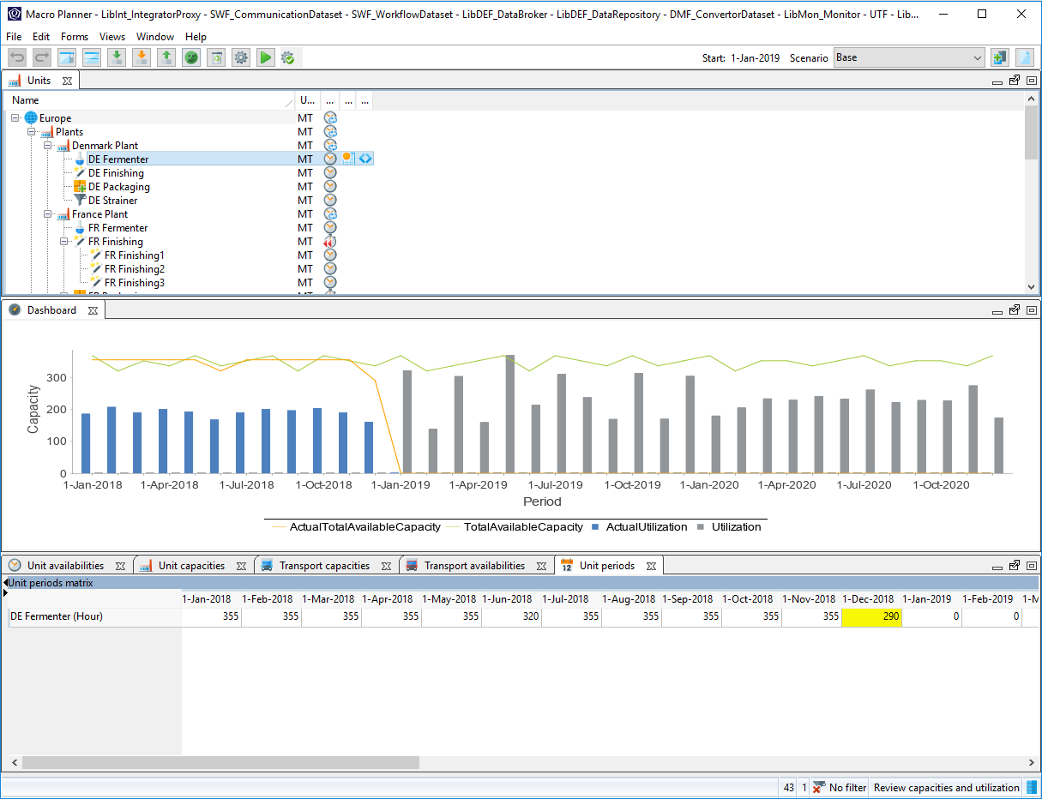

The form ‘Units’ flags the units that you should pay attention to, based on the classification in the global parameters.

Select the unit ‘DE Fermenter’.

This unit is currently flagged to have an outlier when comparing its planned values against actuals. From the chart, it is clear to be seen that the availability prior to the start of planning has seen a stark drop.

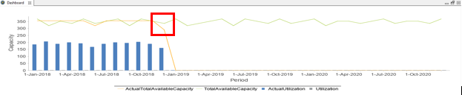

However, after making a few calls to the production floor, we have gathered that the drop was a result of an unscheduled maintenance. In this occurrence, we will resolve this by annotating this in the application.

Select the tab ‘Unit periods’.

Scroll horizontally until you find a highlighted cell.
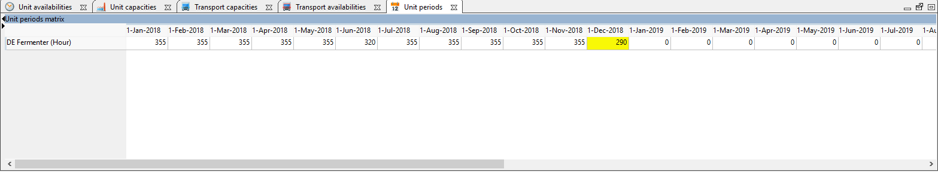

Annotate the occurrence by double-clicking on the cell and leaving a description.
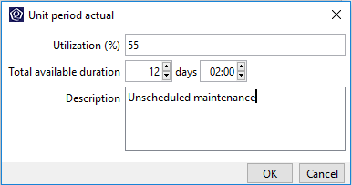

Now that we are done with the reviewing of data, we are going to proceed to analyzing the plan. Before moving to the next step, we are just going to mark the current activity of reviewing the capacities and utilization as complete.
Go to view ‘Activities’ and put a check next to the ‘Review capacities and utilization’ item in ‘My activities’ list.

Analyze the base plan
Go to view ‘Create supply plan’.

Show the navigation panel and navigate to root.
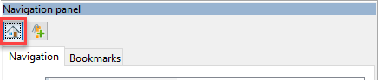

In this view, you will go through with the audience on how to analyze the base plan, do it at an appropriate pace so that the audience can follow.

This is the base plan. We are now going to examine the interesting aspects of this base plan.

The optimizer run on the base plan shows a deficit on the ‘Carrefour’ and ‘Target’ segments in both Germany and Austria. We will now explore the possibility of improving the service levels rendered to these segments.
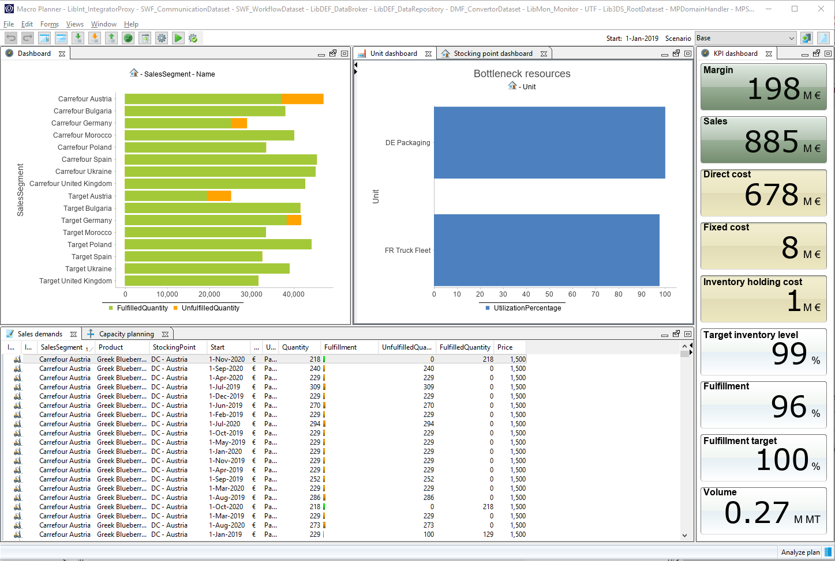

We start off first by identifying products which are sold in these sales segments.

Drill down (double-click) onto bar chart ‘Carrefour Austria’ on the dashboard to see the deficit on a product in stocking point level.

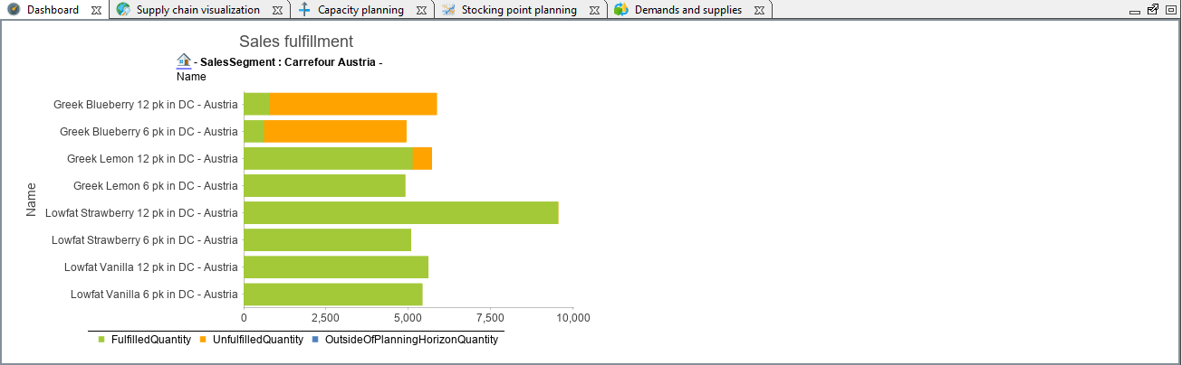
From the drill down, it is clear that the deficit only happens to certain products.

Now that we have narrowed down the products in question, we can make use of the supply chain visualization to identify the bottlenecked resource.

Show the navigation panel and select the tab ‘Bookmarks’.

Open the bookmark ‘Bottlenecked products in DC – Austria’.

Select the tab ‘Supply chain visualization’.

Select any product in stocking point in period of ‘Greek blueberry 12 pk’ in ‘DC – Austria’ on the form ‘Product planning matrix’.

The ‘Supply chain visualization’ shows both the upstream and downstream supply chain with the selected product in stocking point in period as a focal point. The visualization includes product in stocking points as well as the processes involved.

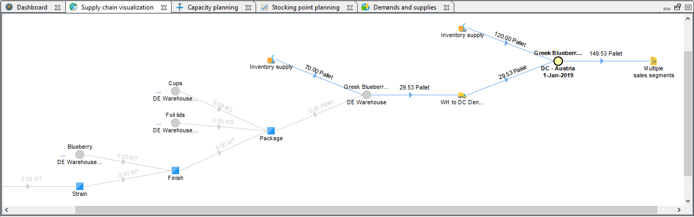

We can see from the ‘Supply chain visualization’ that Greek Blueberry 12pk in DC Austria can only be supplied from the Denmark plant. We will now verify whether there are bottleneck resources on the plant that would be responsible for the fulfillment issue.

Select the tab ‘Capacity planning’.

Show the navigation panel and select the tab ‘Bookmarks’.

Open the bookmark ‘Denmark plant’.
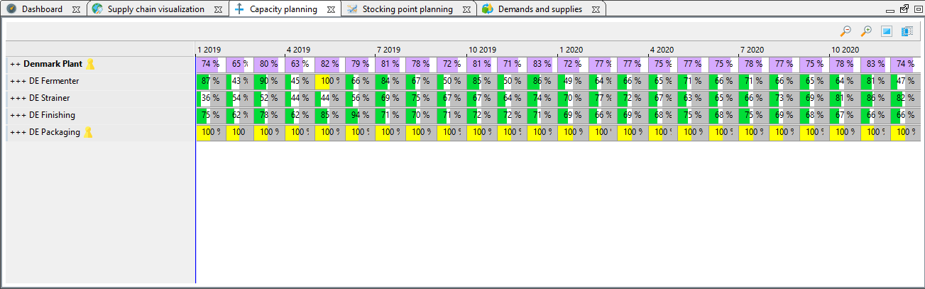

The capacity planning charts shows that the packaging line in the Denmark plant is fully utilized. However, it is also obvious from the capacity planning chart that ‘DE Packaging’ is not operating at its maximum capacity. This will become the basis of our first what-if scenario.

Create what-if scenario
A what-if scenario is a sand-boxed environment isolated from the base plan which you can use to experiment and simulate potential scenarios.

Click on the ‘Copy current scenario’ button on the toolbar.

You will be presented with a dialog with options for your what-if scenarios.

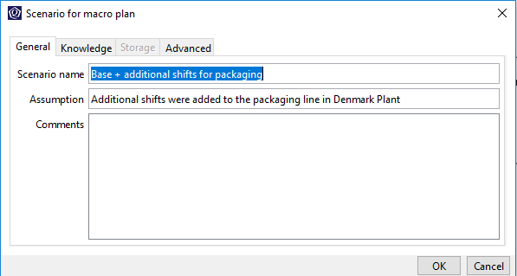

NB. If the application does not allow you to create a copy of the scenario, this is because you reached the maximum number of online scenarios. You can increase this maximum number in the sizing parameters by selecting Edit > Configuration > Sizing parameters (not available on the cloud). Alternatively, you can delete some scenarios in the Manage and compare scenarios view.

Fill in the appropriate fields and click on ‘OK’.

A what-if scenario is now created and that scenario is now made the active scenario as evident from the scenario drop-down.

Scenario: Base + additional shifts for packaging
In this what-if scenario, we are going to explore the possibility of increasing the shifts on the packaging line in Denmark Plant and observe the consequences.

Edit the capacity of the unit ‘DE Packaging’ using the context menu ‘Edit capacity’ on the capacity planning chart.

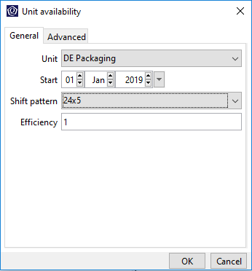

Change the active shift pattern to ‘24x5’.

Click on ‘OK’.

Realize that the unit ‘DE Packaging’ is now no longer fully utilized. This is because that we have just used a greater shift pattern which allows the unit to operate 24 hours and 5 days a week.

After updating the supply chain parameters, the packaging line now have additional capacities. The tradeoff for these additional capacities is the increase in staffing costs, denoted by the fixed costs KPI. An optimizer run is necessary to update the plan based on the new parameters.

Click on the ‘Run the optimizer with the last used settings’ button.

The optimizer run will proceed in the background and it will take anytime less than a minute, in the meantime, you can take this opportunity to explain the configurations of the optimizer and how it can provide the user with goal-based optimization.

Click on the ‘Open optimizer dialog’ button.

The optimizer dialog will appear.

Click on the ‘Edit strategy’ button to bring up the strategy dialog.
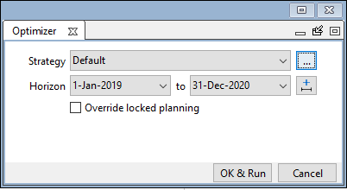

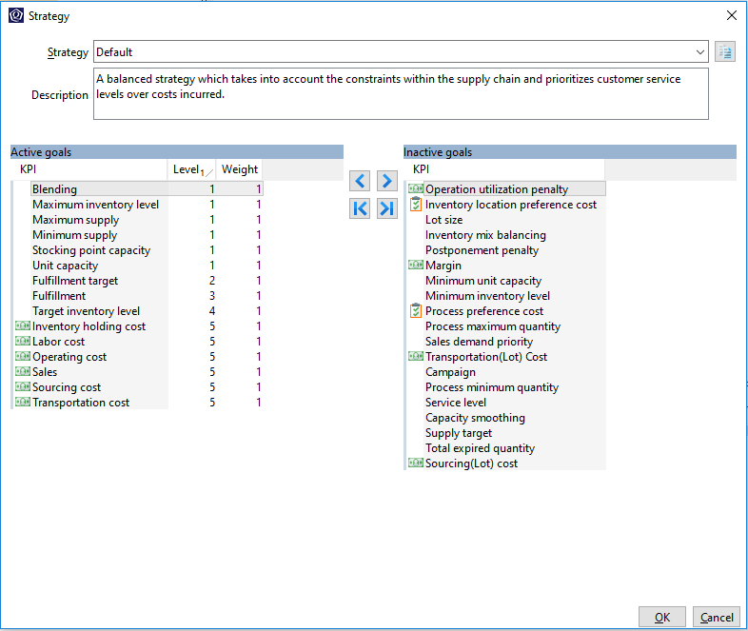

The Macro Planner optimizer uses a KPI-based optimization approach, which allows the planner to create supply plans which aligns with the business goals and strategies of their organization.

The key message here is that the Macro Planner optimizer will not play its traditional role of obtaining the most optimized supply plan in the shortest time, but rather, it serves as tool for the planner to plan the many possible scenarios, taking into account the business strategies and goals of their organization. And finally evaluate the scenarios.
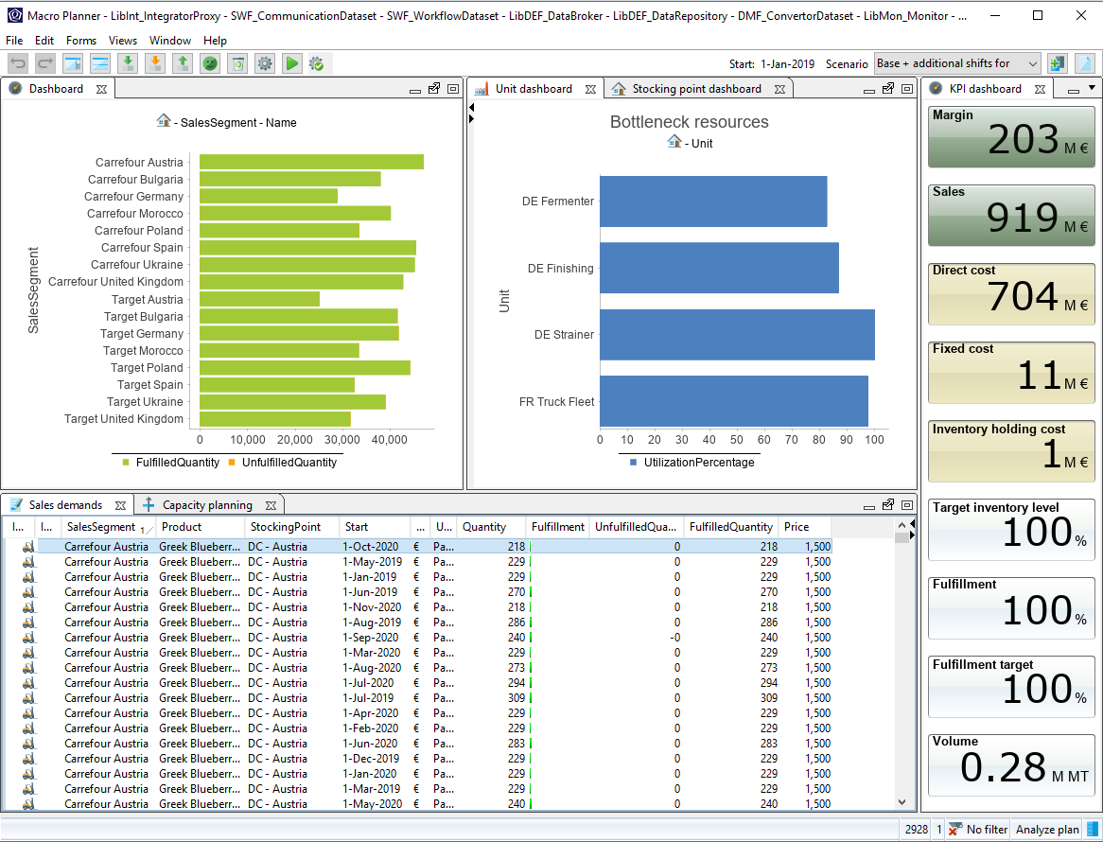

Go to view “Analyze plan”
With the optimization run completed, we are now going to compare the changes in KPIs.

Compare scenarios
Go to view ‘Manage and compare scenarios’.

Select both the scenarios ‘Base’ and ‘Base + additional shifts for packaging’.

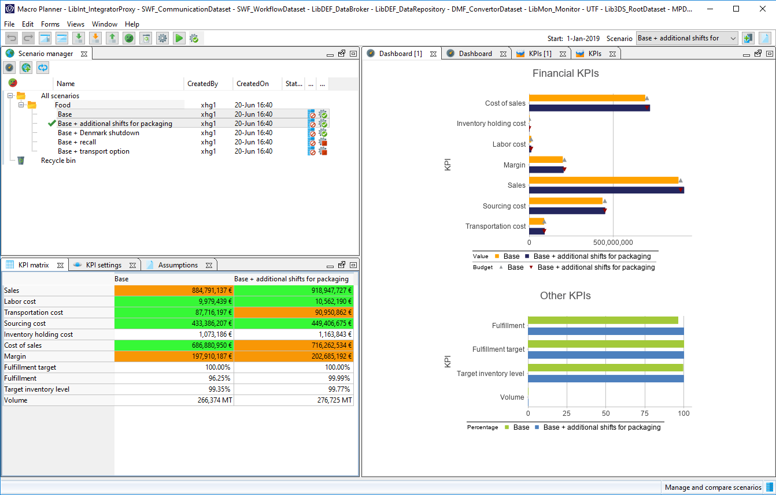

Realize that the ‘Fulfillment’ KPI has improved from 96% to 100%. The gains in the ‘Fulfillment’ KPI is clear to be seen. However, people will often ask what is the trade-off, if there are any, in achieving this?

If you have a keen eye, you would have realized by now, that there is an increase in the cost of sales.

What was discussed above are the high-level comparisons in the form of KPIs, which will certainly interest the management. However, S&OP is an integrated business management process which encompasses many people from different departments. With the additional shifts, we are now going to see the effects of this what-if scenario on the resource utilization.

Select both the scenarios ‘Base’ and ‘Base + additional shifts for packaging’.

Compare the resource availability and utilization by using the context menu ‘Compare’ followed by ‘Unit periods’ with both the scenarios selected.
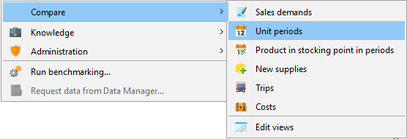

You will be presented with a new view.

Show the navigation panel and select the tab ‘Bookmarks’.

Open the bookmark ‘DE packaging’.

The view will now look like this.
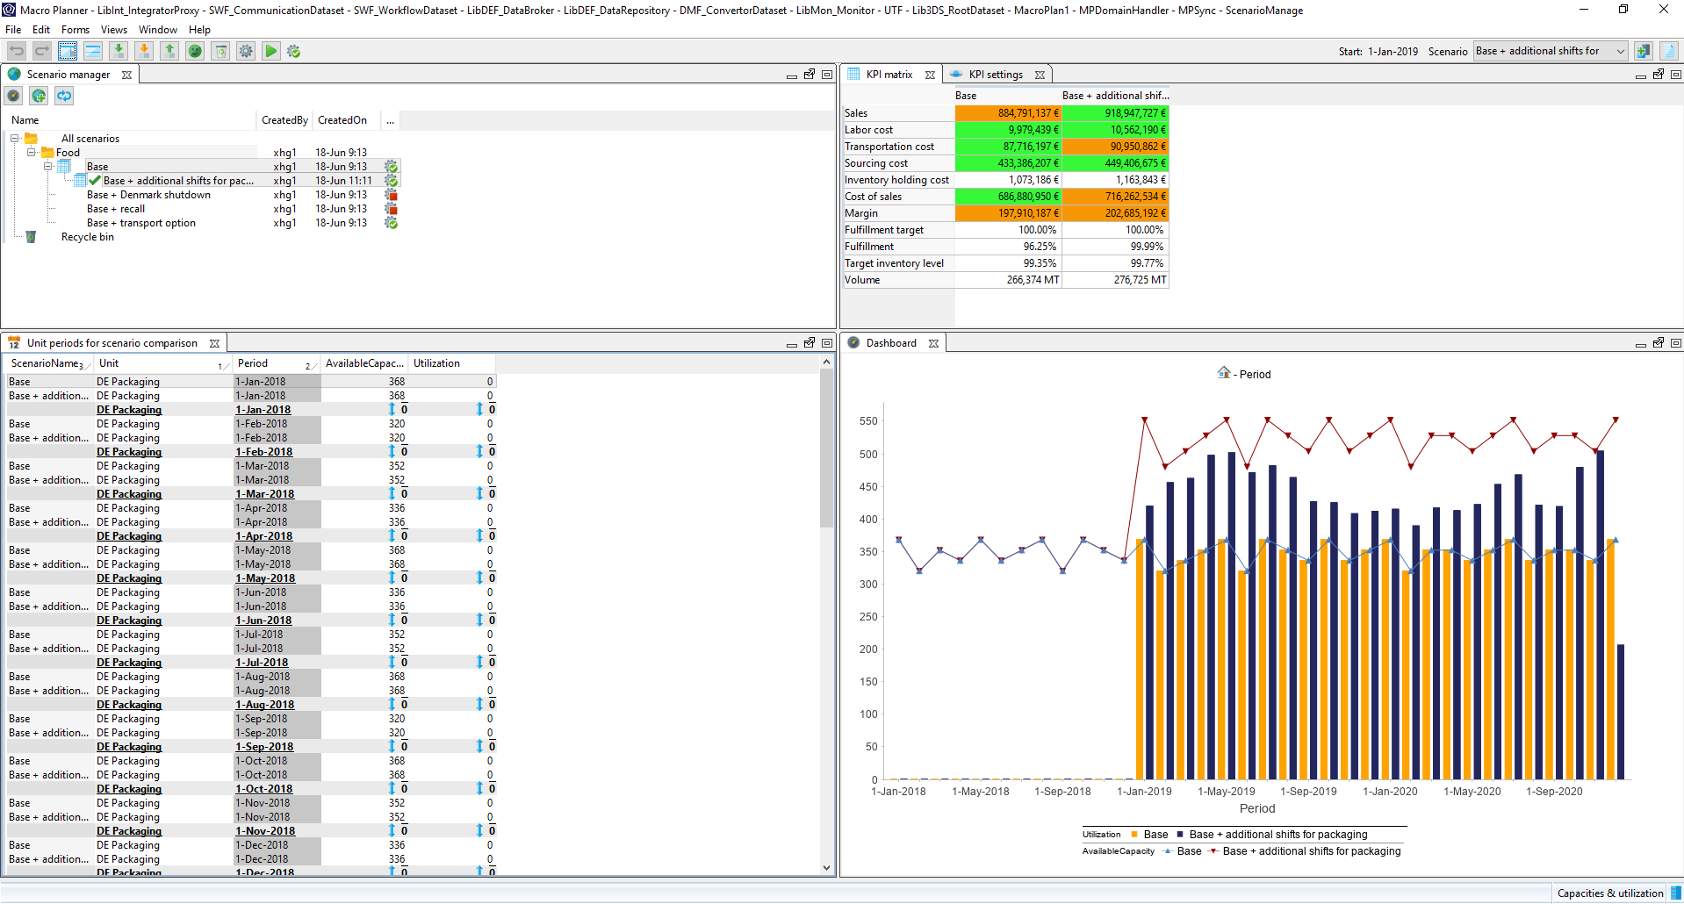

It is clear from the dashboard charts comparing the capacities, that the increase in availability of the packaging line are utilized.

OPTIONAL

Optionally, you can demo the robustness of the scenario comparison by demonstrating the comparison of output quantities.

With the additional shifts, the production manager is now interested in seeing the effects of this what-if scenario on the output quantities.

Select both the scenarios ‘Base’ and ‘Base + additional shifts for packaging’.

Compare the output quantities by using the context menu ‘Compare’ followed by ‘New supplies’ with both the scenarios selected.

Show the navigation panel and select the tab ‘Bookmarks’.

Open the bookmark ‘DE packaging’.

You will be presented with a view which shows the output quantities for the different finished goods.
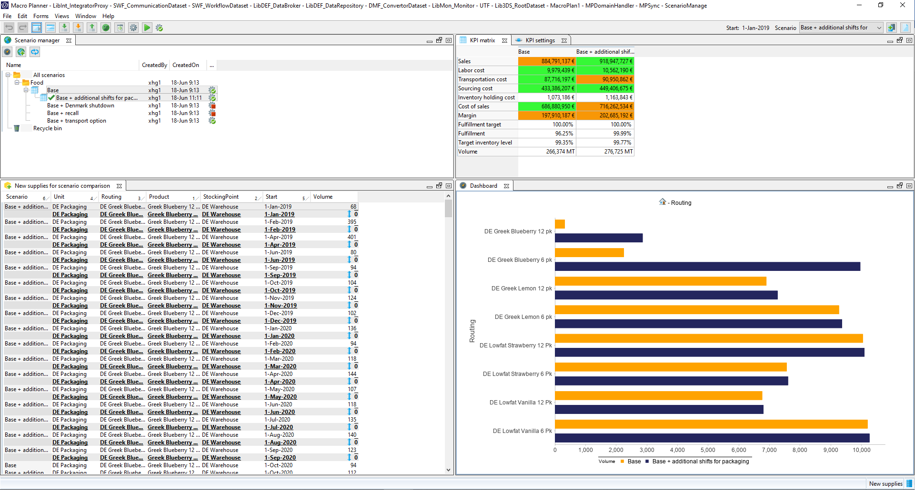

All in all, by comparing the scenarios, you are now equipped with sufficient knowledge and are clear about the trade-offs, which can be useful during the discussion in the S&OP meeting. Next up, we would like to determine the viability of the scenario by running it through the relevant departments, in this case, subjecting the proposal to the verification of the Human Resource department.

Create scenario activity
Process and workflow support are important elements of an S&OP implementation. For the what-if scenario of additional shifts on the cold mills of Qi-Ying, we are going to create an activity for the factory manager to review and verify the additional shifts.

Go to view ‘Activities’.

Click on the button ‘New’.

On the activity dialog, fill in the following:
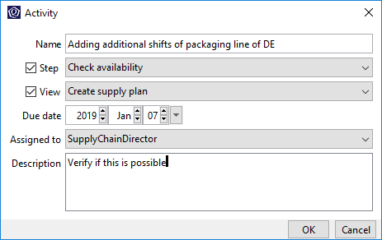

Click on ‘OK’.

This would then create an activity for the Supply chain director, which would be visible the next time he or she logs in to the Quintiq application.

Scenario: Base + transport option

Remember to already create a scenario for this, load the appropriate data and run the optimizer, as the following steps will not cover these. Instead, these are covered in the ‘Preparation’ section.

During the analysis of the base plan, we realized that the packaging line in Denmark was not the only bottleneck in the supply chain, but also our truck fleet in France.

Select the scenario ‘Base’.

Go to view ‘Analyze plan’.

Select tab ‘Capacity planning’.

Show the navigation panel and select the tab ‘Bookmarks’.

Open the bookmark ‘Transportation’.
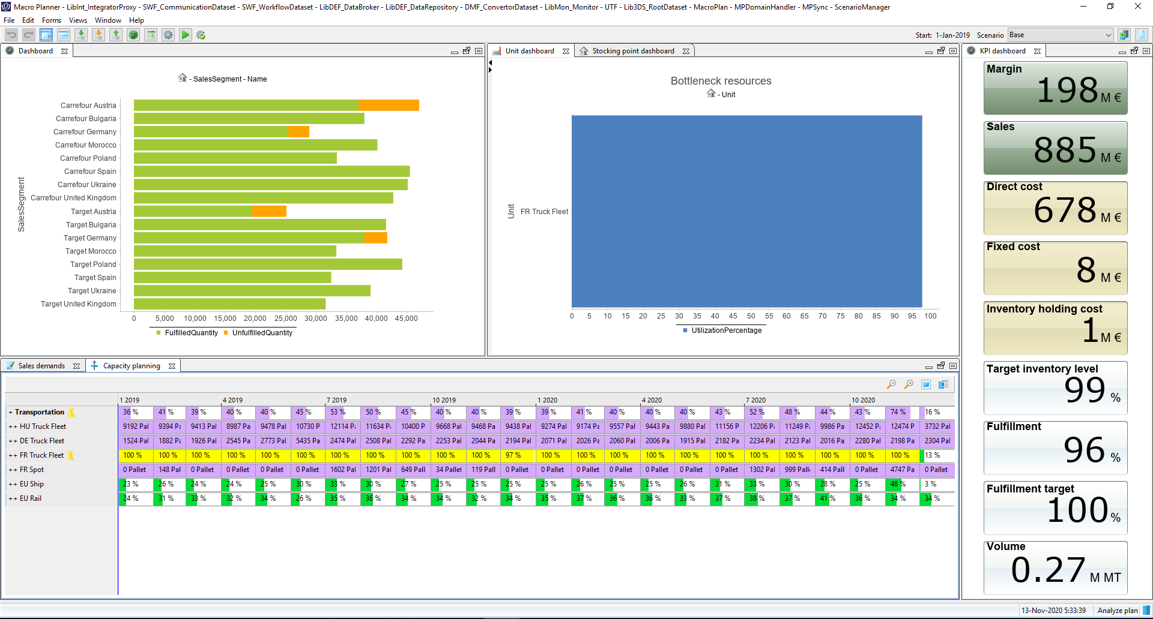

It is clear that the unit ‘FR Truck Fleet’ is a constant bottleneck, which also resulted in us turning to the spot market for additional transportation capacities. This has resulted in high transportations costs due to the high prices of the spot market.

In the meantime, the logistics team has also been working on an alternative provider, who is able to provide us with the required capacity, albeit at a slightly higher price. With this piece of information, we are now going to evaluate the possibility of replacing our current provider with this new provider.

Select the scenario ‘Base + transport option’.

Go to view ‘Update lanes’.

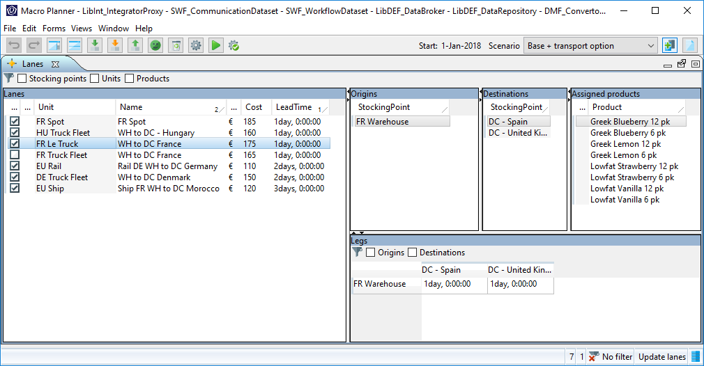

Select the lane ‘WH to DC France’ of ‘FR Le Truck’.

We have added a lane, which services the same locations as the existing truck fleet in France, at a higher cost and availability.

We are now going to analyze and compare this hypothetical scenario against the base scenario in more detail.

Go to view ‘Manage and compare scenarios’.

Select both the scenarios ‘Base’ and ‘Base + transport option’.
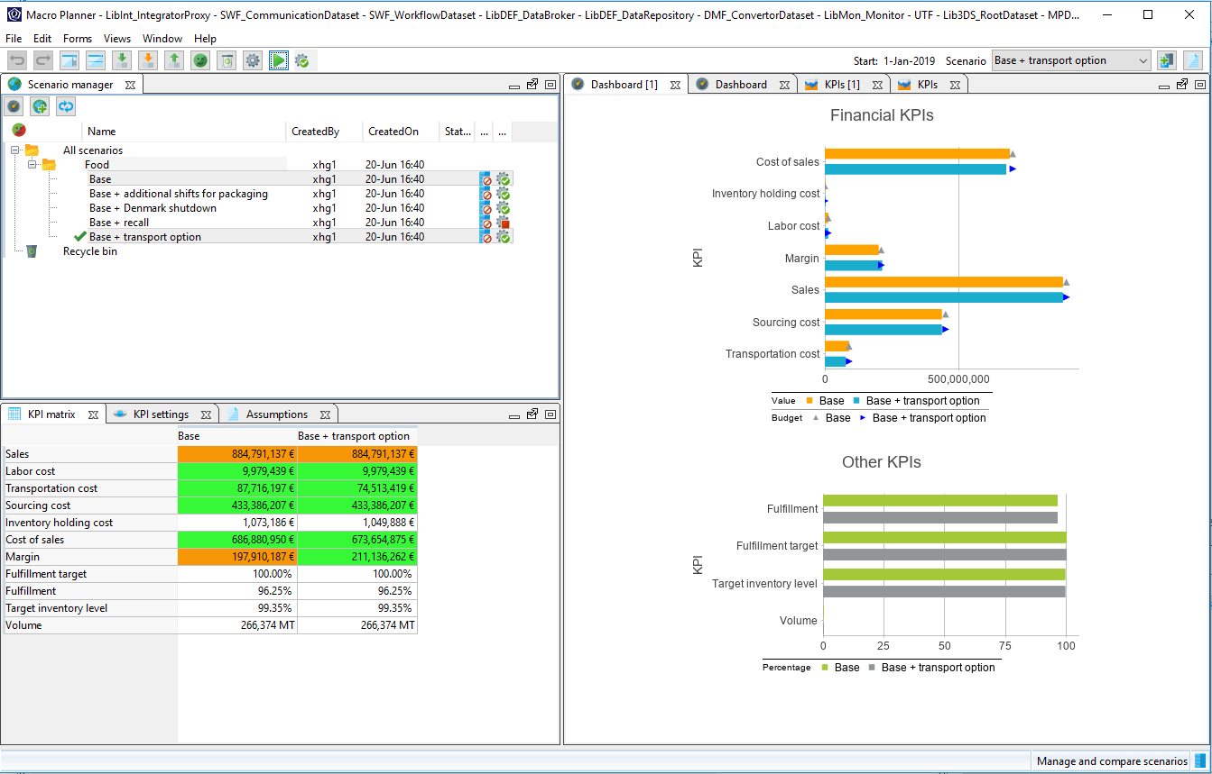

The KPI comparison shows the reduction in transportation costs. Perhaps contracting a new logistics provider that is capable of providing us with the required capacity though at a higher cost, is in the larger scheme of things, cheaper than turning to spot providers.

OPTIONAL

You can also create a scenario activity for the logistics manager to examine the possibility of this scenario.

Scenario: Base + Denmark shutdown
Remember to already create a scenario for this, load the appropriate data and run the optimizer, as the following steps will not cover these. Instead, these are covered in the ‘Preparation’ section.

In this what-if scenario, we are going to analyze the impact of a short term closure of the Danish plant and what steps can be taken to minimize the impact to our business. This is triggered by a long overdue maintenance of the plant.

Select the scenario ‘Base + Denmark shutdown’.

Run the optimizer.

Go to view ‘Update supply chain constraints’.

Select the tab ‘Unit availabilities’.
Show the navigation panel and select the tab ‘Bookmarks’.

Open the bookmark ‘DE Fermenter’.
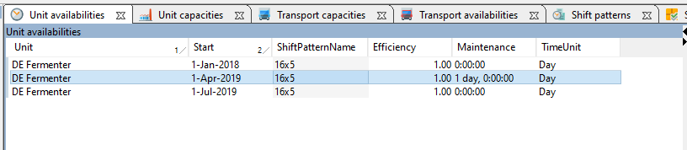

We have added a constraint for the Fermenter in the Denmark plant to be shuttered for 3 months starting from the month of April to June.

We are now going to evaluate the impact and compare this hypothetical scenario against the base scenario.

Go to view ‘Manage and compare scenarios’.

Select both the scenarios ‘Base’ and ‘Base + Denmark shutdown’.

The KPI comparison shows the significant reduction in fulfillment and margin. Next up, the account managers are going to be very interested in seeing how the reduction in fulfillment is going to affect their customers.

Select both the scenarios ‘Base’ and ‘Base + Denmark shutdown’.

Compare fulfillment by using the context menu ‘Compare’ followed by ‘Sales demands’ with both the scenarios selected.

Show the navigation panel and navigate to root.

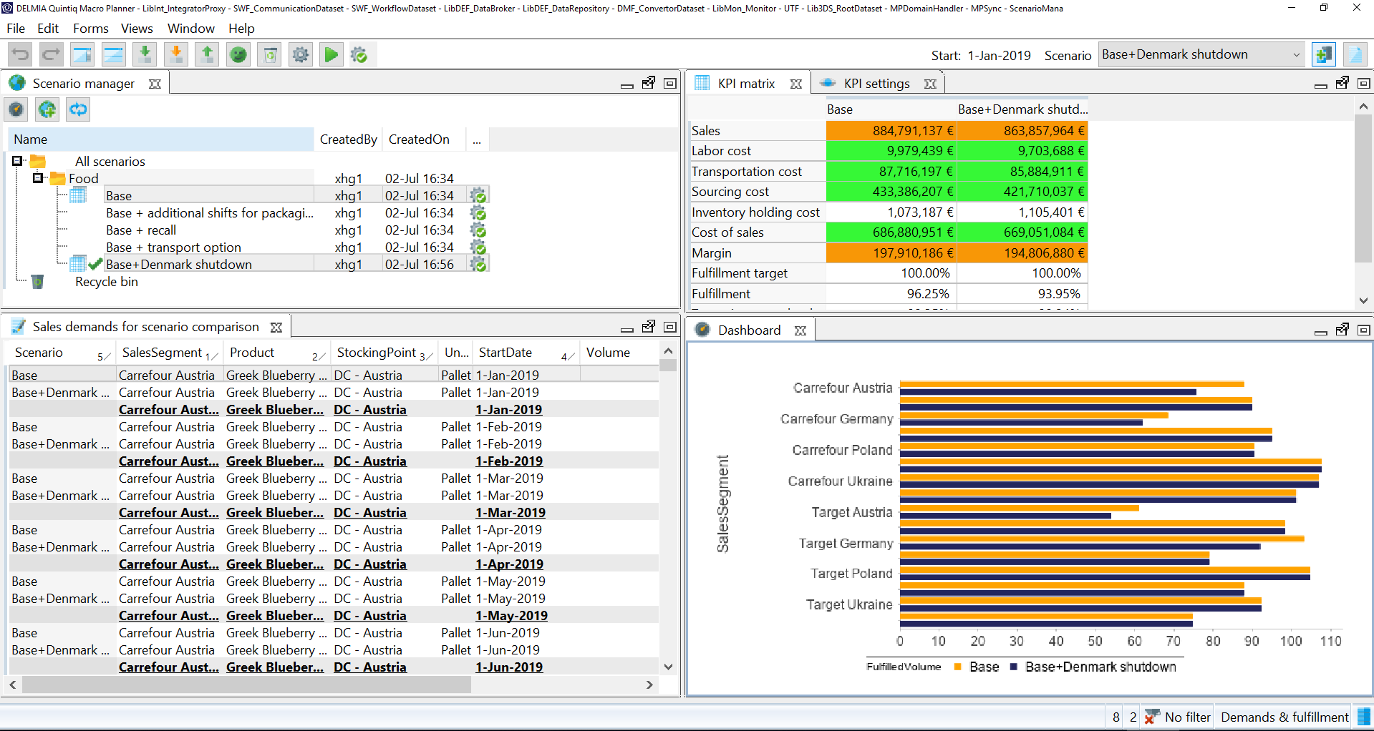

We can see that both Carrefour and Target in both Austria and Germany are affected by the plant closure. The benefit of comprehensive S&OP tool is clear to see here, where the organization can spot opportunities, and improve the overall efficiency of the supply chain.

OPTIONAL

You can also create a scenario activity for the sourcing manager to examine the possibility of this scenario.

Knowing that our French plant is underutilized, the production manager is suggesting that we make use of the available capacities in the French plant as well as spot transportation to cater to our customers in Austria and Germany. Yet our current network has no transportation lane defined from France to Austria and Germany. Let’s create this lane.

Go to the view ‘Update lanes’.

Check the checkbox of lane ‘FR Transshipment’ of ‘FR Spot’.

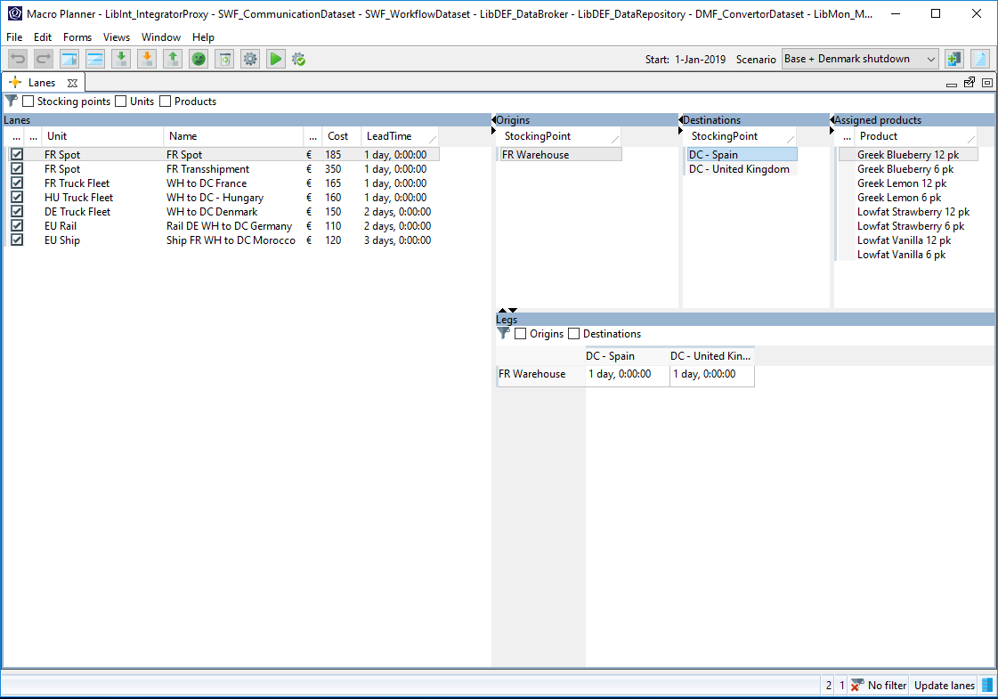

Click on the ‘Run the optimizer with the last used settings’ button.

The optimizer run will proceed in the background and it will take anytime less than a minute, in the meantime, you can take this opportunity to explain the configurations of the optimizer and how it can provide the user with goal-based optimization.

With the optimization run completed, we are now going to evaluate the remedy put in place for the plant shutdown and compare the changes in KPIs against the base plan, which acts as a benchmark.

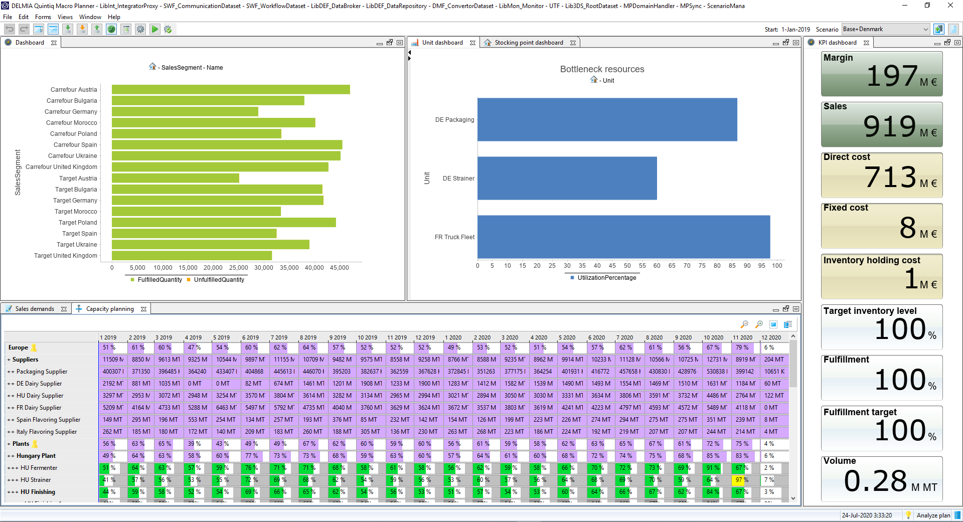

Go to view ‘Manage and compare scenarios’.

Select both the scenarios ‘Base’ and ‘Base + Denmark shutdown’.

Comparing against the base plan, we see an increase in sales as well as fulfillment. However, this gain is offset by the higher transportation and labor costs, resulting in a lower margin overall. With the increased utilization of the plant, the French production manager is also very interested in seeing the production forecast of their plant.

Select both the scenarios ‘Base’ and ‘Base + Denmark shutdown’.

Compare the production numbers by using the context menu ‘Compare’ followed by ‘New supplies’ with both the scenarios selected.

Show the navigation panel and select the tab ‘Bookmarks’.

Open the bookmark ‘FR Packaging’.
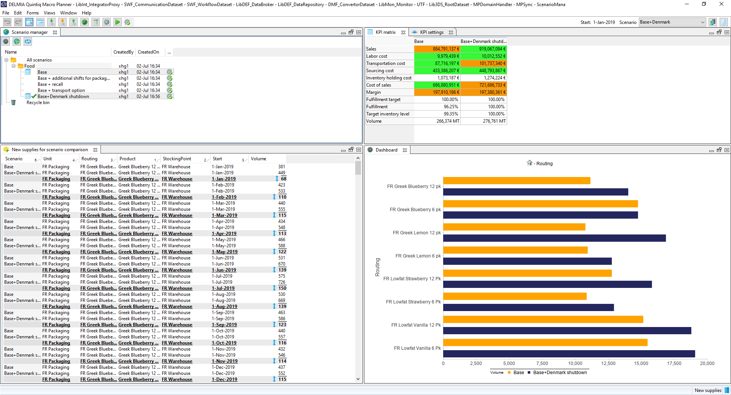

It is here where we can see the increase in production across the board for all the product group manufactured in the French plant.

OPTIONAL

You can also create a scenario activity for the production manager to examine the possibility of this scenario.

Scenario: Base + recall
Remember to already create a scenario for this, load the appropriate data and run the optimizer, as the following steps will not cover these. Instead, these are covered in the ‘Preparation’ section.

In this what-if scenario, we are going to analyze the impact of a recall of finished goods on our business. This is triggered by a labelling error, picked up fairly early in the Danish warehouse before it is being shipped to the delivery centers.

Select the scenario ‘Base + recall’.

Run the optimizer.

Go to view ‘Update routings’.

Select the routing ‘DE Lowfat Vanilla 6 Pk Rework’.

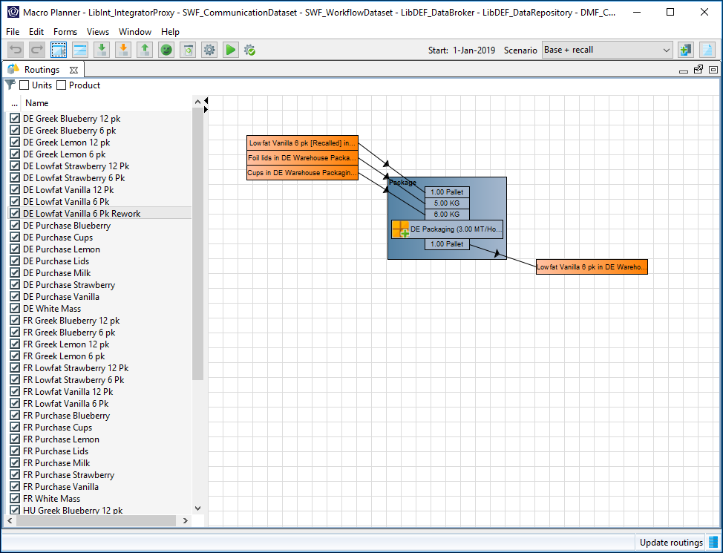

A new item has been created to represent the recalled goods, where the inventory of the original goods are removed and fed back as inventory receipts for the new item. These goods are then fed back into the normal labelling process. The costs involved in the recall and rework process is also recorded on a separate account, for recording and accounting purposes.

We are now going to analyze the impact of the recall and rework.

Go to view ‘Manage and compare scenarios’.

Select both the scenarios ‘Base’ and ‘Base + recall’.

The KPI comparison shows the reduction in fulfillment and margin. The rework cost is also clear to be seen, as it is recorded as a separate KPI (if needed, check Rework cost in KPI settings form). On top of that, the warehouse manager would also like to see if the recall has affected his safety stocks.

Compare the inventories by using the context menu ‘Compare’ followed by ‘Product in stocking point in periods’ with both the scenarios selected.

Show the navigation panel and select the tab ‘Bookmarks’.

Open the bookmark ‘Lowfat Vanilla 6pk in DE Warehouse’.
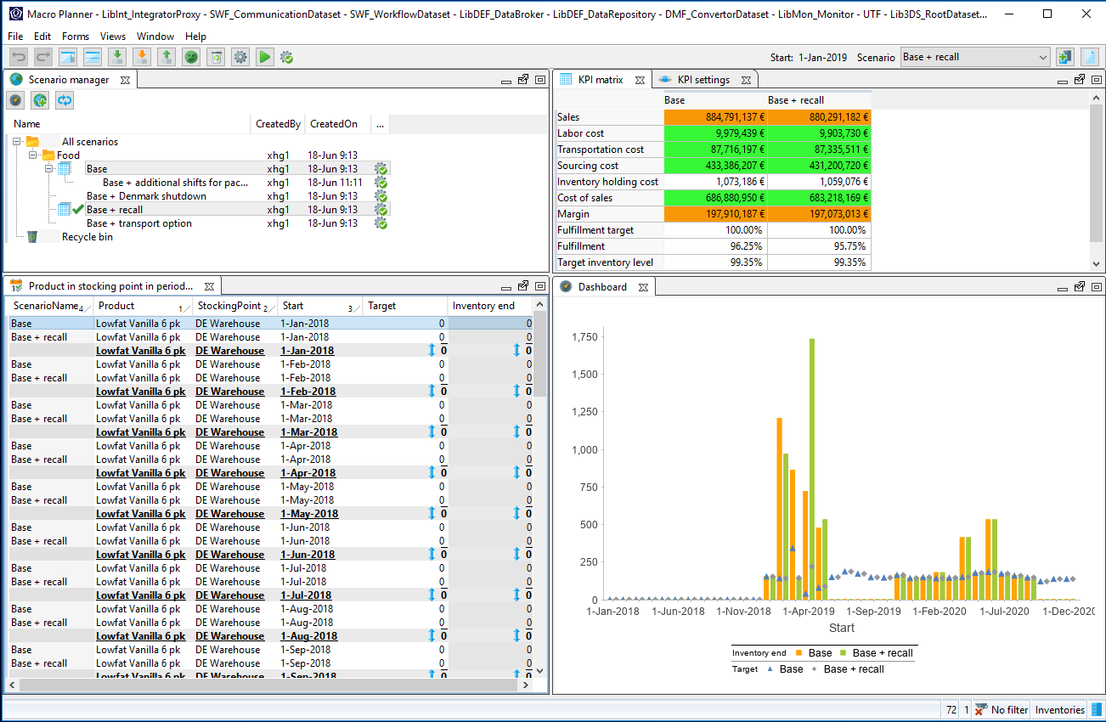

The warehouse manager would be glad to know that, although the inventory levels of the product is affected, it has never missed the safety stock threshold during the recall period.

OPTIONAL

You can also create a scenario activity for the warehouse manager to examine the possibility of this scenario.

Scenario: Base + adjust fulfillment
In this what-if scenario, we realized that demand for a particular product which we have been trying to increase its market share has not been fulfilled due to capacity constraints in our base supply plan. The consensus was to channel the production capacity reserved for another product to this particular product.

Create a copy of the Base scenario. Click on the ‘Copy current scenario’ button on the toolbar.

NB. If the application does not allow you to create a copy of the scenario, this is because you reached the maximum number of online scenarios. You can increase this maximum number in the sizing parameters by selecting Edit > Configuration > Sizing parameters (not available on the cloud). Alternatively, you can delete some scenarios in the Manage and compare scenarios view.

You will be presented with a dialog with options for your what-if scenarios.
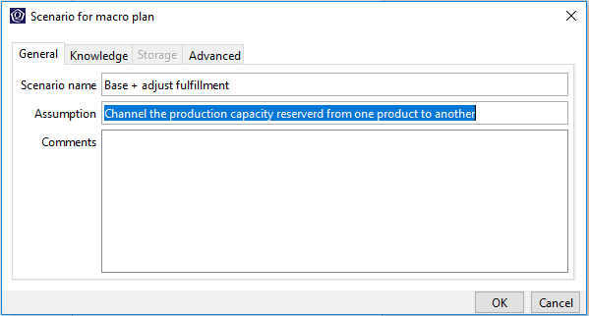

Fill in the appropriate fields and click on ‘OK’.

A what-if scenario is now created and that scenario is now made the active scenario as evident from the scenario drop-down.

Go to view ‘Create supply plan’.

Open the bookmark ‘Greek Blueberry 12 pk in DC - Austria’.

The chart ‘Sales fulfillment’ clearly shows the low fulfillment numbers for sales segments carrying this product.

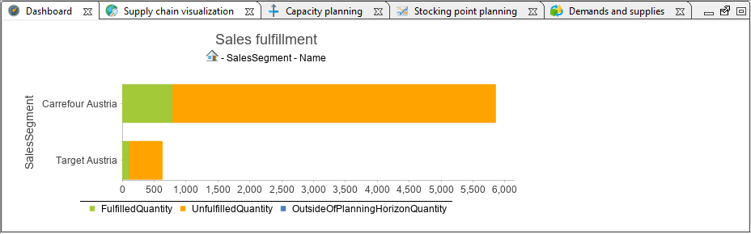

First, we adjust the supply plan to fulfill demands for this product in the first period via the product planning matrix.

Select the cell in the form ‘Product planning matrix’ bearing the product in stocking point ‘Greek Blueberry 12 pk in DC - Austria’ in the period ‘1-Jan-2019’. Bring up the context menu and select the option ‘Smart plan…’.

On the dialog ‘Smart plan’, check the option ‘Total supply’ and enter a value of 250, which is equivalent to the total demand of that product in that period. Subsequently, select the tab ‘Advanced’ and select the radio option ‘Upstream’. Click on ‘OK’.

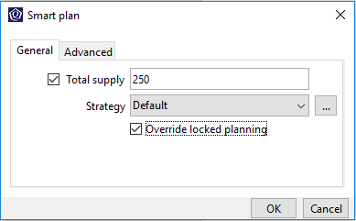

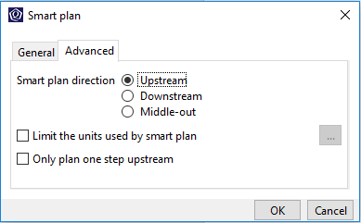

This will trigger an upstream Smart plan run with the specified quantity on the product in stocking point in period. Smart plan can be described as optimizer-supported manual planning / local planning. Depending on the direction of the Smart plan, in this case ‘Upstream’, Smart plan would ensure that the upstream relative to the selected product in stocking point in period is planned based on the specifications (e.g. total supply).

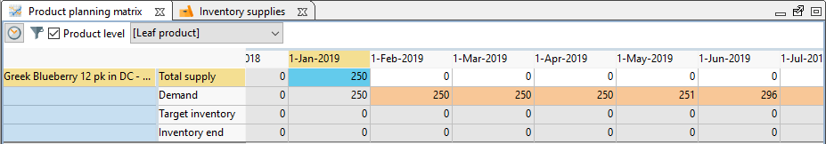

The adjustment made earlier would have resulted in a capacity constraint violation. This is evident for the unit ‘DE Packaging’ under the unit ‘Denmark plant’ as visualized in the form ‘Capacity planning’.

Open the bookmark ‘Denmark plant’.

Select the tab ‘Capacity planning’.
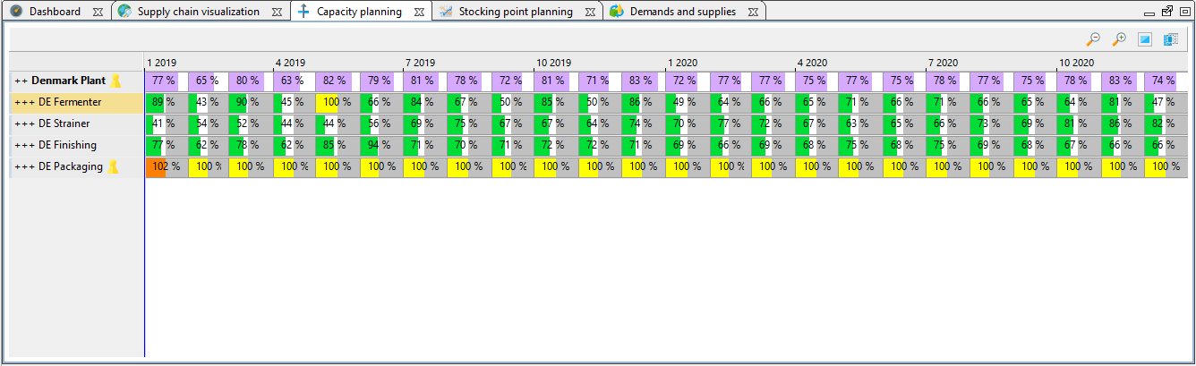

Now, using the supply chain visualization, we want to identify the upstream of the product which we adjusted the supply. The visualization is based on the selected product in stocking point in period of the product planning matrix.

Open the bookmark ‘Greek Blueberry 12 pk in DC - Austria’.

Select the tab ‘Supply chain visualization’.

Select the cell in the form ‘Product planning matrix’ bearing the product in stocking point ‘Greek Blueberry 12 pk in DC - Austria’ in the period ‘1-Jan-2019’.

This would then lead us to the product in stocking point ‘White Mass in DE Warehouse’.

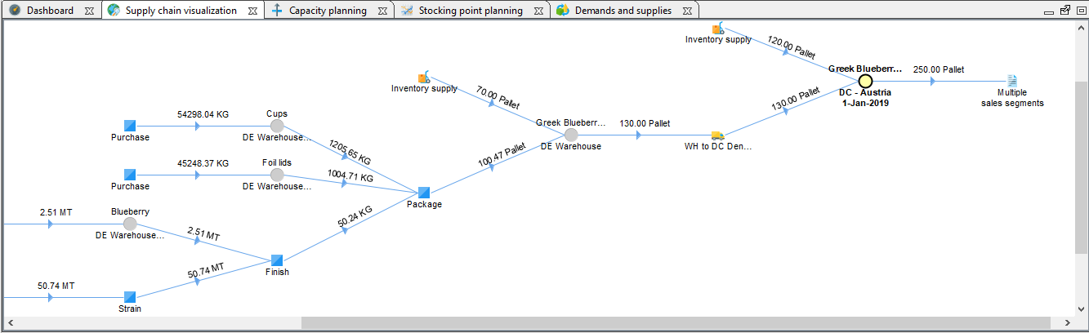

Using the supply chain visualization again, we want to identify all the downstream finished goods which utilizes the product ‘White Mass’ as an input product, which is the input product prior to the bottleneck identified in the capacity review earlier.

Select the tab ‘Supply chain visualization’.

Double-click on the node ‘White mass in DE Warehouse Raw Material’.

This would now make the selected product as a focal point in the supply chain visualization, allowing us to visualize the downstream supply chain of this product.
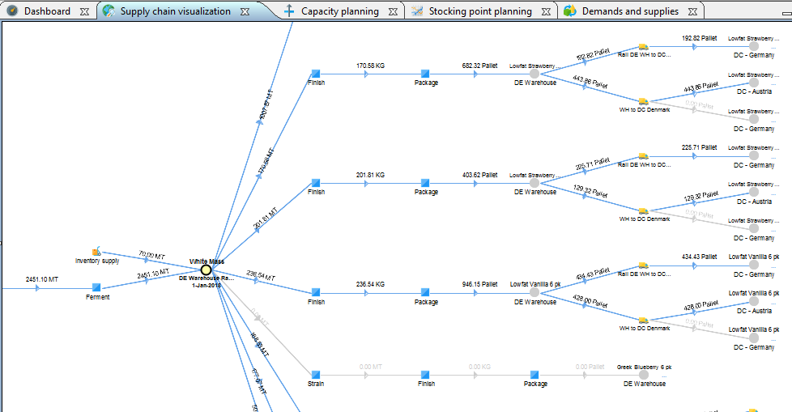

After taking into consideration all the downstream products, we have achieved a consensus with our sales team that we want to reduce the production capacity reserved for the product in stocking point ‘Lowfat Vanilla 6 pk in DC – Germany’ so as to balance out the additional supply created earlier.

Select the tab ‘Supply chain visualization’.

Click on the node ‘Lowfat Vanilla 6 pk in DC - Germany’.

The selected product in stocking point will now appear as a new entry in the product planning matrix. We will now use Smart plan again to determine the reduced supply quantity for the product in stocking point in period.

Select the cell in the form ‘Product planning matrix’ bearing the product in stocking point ‘Lowfat Vanilla 6 pk in DC - Germany’ in the period ‘1-Jan-2019’. Bring up the context menu and select the option ‘Smart plan…’.

On the dialog ‘Smart plan’, uncheck the option ‘Total supply’. Subsequently, select the tab ‘Advanced’ and select the radio option ‘Upstream’. Click on ‘OK’.

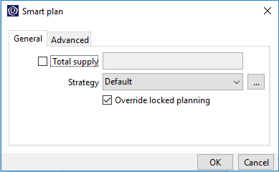

This will now trigger an upstream Smart plan run which Smart plan would determine the optimized supply quantity at the same time adhering to the assigned strategy. The reduction in supply is evident on form ‘Product planning matrix’.
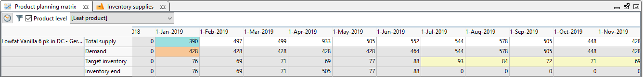

Finally, we are going to verify that the capacity constraint violated earlier has now been resolved.

Open the bookmark ‘Denmark plant’.

Select the tab ‘Capacity planning’.

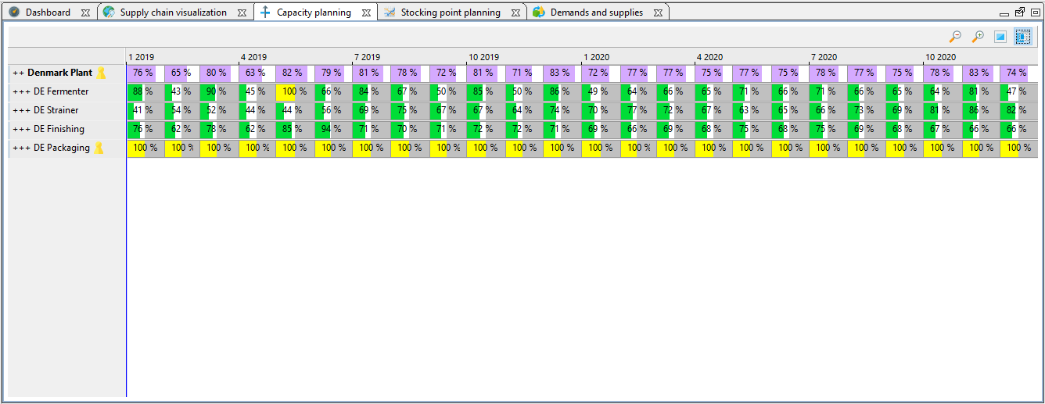

We can see that it is indeed feasible for us to channel our reserved production capacity to another product. We can now work towards supply plan which would allow us to increase the market share of the particular product.

OPTIONAL

You can also create a scenario activity for the factory manager to examine the possibility of this scenario.

Summary
Feel free to create your own what-if scenarios to align to the interest of your prospect.

Further align the demo of comparison between the what-if scenarios to the business goals and strategies of the prospect that you are pitching to, by making use of the functionality to compare scenarios in detail.

Also emphasized that planning and decision-making are driven by KPIs.

These scenarios give us a powerful ability to complete a full S&OP cycle rapidly and make assessments of all the opportunities which may exist. The ability to represent your physical supply chain accurately, rapidly change the supply chain and constraint data, in a S&OP process driven structure set up for the optimization runs to produce the plans. You then select the right strategy for optimization, and then run and compare multiple scenario’s giving your S&OP the power needed to ensure that the Executive SOP Meeting is fully informed of all the opportunities and can make the best choices with the complete set of information available.

